Letter dated 15 January 2024 from the Panel of Experts on the Sudan addressed to the President of the Security Council

The Panel of Experts on the Sudan established pursuant to Security Council resolution 1591 (2005) has the honour to transmit herewith, in accordance with paragraph 2 of resolution 2676 (2023), the final report on its work.
The report was provided to the Security Council Committee established pursuant to resolution 1591 (2005) concerning the Sudan on 22 December 2023 and was considered by the Committee on 15 January 2024.
The Panel would appreciate it if the present letter and the report were brought to the attention of the members of the Security Council and issued as a document of the Council.

(Signed) Laura Victoria Bernal Moncada
Coordinator
Panel of Experts on the Sudan
(Signed) Amber Larsen
Expert
(Signed) Andrei Kolmakov
Expert
(Signed) Thomas Wanjala
Expert
(Signed) Vincent Darracq
Expert

Final report of the Panel of Experts on the Sudan

Summary
By mid-December 2023, the Rapid Support Forces (RSF) had secured control of four of five Darfur states, including strategic cities, supply routes and border areas. RSF captured Sudanese Armed Forces (SAF) headquarters in South Darfur (Nyala on 26 October), Central Darfur (Zalingei on 31 October), West Darfur (Ardamatta on 4 November) and East Darfur (Ed Daein on 22 November). The operation was supervised by Abdelrahim Dagalo (RSF deputy commander-in-chief). During the first phase of the conflict (April to July 2023), RSF seized large parts of Darfur, including important SAF bases in localities such as Kutum, Kabkabiyah (North Darfur) and Am Dafok (South Darfur). SAF retained a presence only in North Darfur State, in particular its headquarters in El Fasher, which RSF refrained from attacking after informal negotiations with the Darfurian armed movements there.
As the RSF advanced, violence against civilians swept through Darfur. In West Darfur (El Geneina, Sirba, Murne and Masteri), RSF and allied militias targeted the Masalit community in particular. RSF allied militias systematically violated international humanitarian law. Some of those violations may amount to war crimes and crimes against humanity. RSF and allied militias targeted gathering sites for internally displaced persons, civilian neighbourhoods and medical facilities and committed sexual violence against women and girls. In El Geneina alone, between 10,000 and 15,000 people were killed. SAF not only was unable to protect civilians, but also used aerial bombing and heavy shelling in urban areas in El Fasher, Nyala and Ed Daein. That action by the warring parties caused a large-scale humanitarian crisis.
The RSF takeover of Darfur relied on three lines of support: the Arab allied communities; dynamic and complex financial networks; and new military supply lines running through Chad, Libya and South Sudan.
While both SAF and RSF engaged in widespread recruitment drives across Darfur from late 2022 onwards, RSF was more successful. It harnessed substantial support among Arab communities, in particular in South and West Darfur. The war crystallized a feeling of common Arab identity among Arab communities of Darfur (and Kordofan), temporarily suspending old internal rivalries. Native leaders were further motivated by the RSF offerings of cars, money and military ranks. The Arab communities provided RSF with the human resources and local knowledge crucial to quickly capture the main cities and supply routes across Darfur.
Complex financial networks established by RSF before and during the war enabled it to acquire weapons, pay salaries, fund media campaigns, and lobby and buy the support of other political and armed groups. RSF invested large proceeds from its pre-war gold business in several industries, creating a network of as many as 50 companies. RSF senior members and their associates owned and controlled several of those companies in the region. Al Khaleej Bank became instrumental in financing RSF, receiving a $50 million transfer from the Central Bank of Sudan in March 2023.
With that money, the RSF developed new supply lines of military equipment and fuel through eastern Chad, Libya and South Sudan. From July onwards, RSF deployed several types of heavy and/or sophisticated weapons, including unmanned combat aerial vehicles, howitzers, multiple-rocket launchers and anti-aircraft weapons such as man-portable air defence systems. This new RSF firepower had a massive impact on the balance of forces, both in Darfur and other regions of the Sudan. New heavy artillery enabled RSF to swiftly take over Nyala and El Geneina, while its new anti-aircraft devices helped to counter the main asset of SAF, namely, its air force. Meanwhile, SAF could not replenish its Darfur garrisons with any meaningful military supplies, given that RSF had taken control of most portions of the road between Kusti and El Fasher, the main supply route of SAF from Khartoum and Port Sudan.
In the meantime, pressure on the Darfurian armed movements to side with either SAF or RSF triggered divisions among and within the movements. While most armed movements initially publicly adopted a position of neutrality, that stance changed dramatically on 16 November, when several key leaders of armed movements, including Minni Minawi (Chair of the Sudan Liberation Army-Minni Minawi) and Gibril Ibrahim (Justice and Equality Movement Chair) declared their support for SAF. However, the fragmentation within movements was yet to have any effect because forces on the ground refused to join the fighting.
While Darfur was experiencing its worst violence since 2005, various regional and international actors attempted to mediate between RSF and SAF. The combination of an excess of mediation tracks, the entrenched positions of the warring parties and competing regional interests meant that those peace efforts had yet to stop the war, result in a political settlement or address the humanitarian crisis.

Contents
 |  |  | Page
- Introduction |  |  | 5
- Conflict dynamics in Darfur |  |  | 5
- Overview |  |  | 5
- Darfurian armed groups: shattered neutrality and fragmentation |  |  | 7
- Ethnically based recruitment: “militianization” dynamics |  |  | 10
- Weapons supply for the Sudanese Armed Forces and the Rapid Support Forces in Darfur |  |  | 13
- Humanitarian crisis and international humanitarian law violations |  |  | 17
- Case study 1: ethnically targeted violence in El Geneina and Ardamatta |  |  | 20
- Case study 2: conflict dynamics in Nyala |  |  | 30
- Financing of the warring parties in Darfur |  |  | 32
- Mediation initiatives |  |  | 35
- Impact of the situation in Darfur on the region |  |  | 38
- Travel ban |  |  | 40
- Recommendations |  |  | 40
Annexes |  |  | 41

I. Introduction

1. In its paragraph 2 of resolution 2676 (2023), the Security Council requested the Panel of Experts on the Sudan to provide it with a final report no later than 13 January 2024. In the present report, the Panel outlined its findings and investigations since the beginning of its mandate on 12 March 2023.
2. Owing to the security situation, the Panel was unable to visit Darfur. However, the Panel held meetings and conducted telephone interviews with a number of interlocutors, including the Government of the Sudan, the Sudanese Armed Forces (SAF), the Rapid Support Forces (RSF), the Darfurian armed movements, both signatories and non-signatories to the Juba Agreement for Peace in the Sudan, representatives of civil society, including internally displaced persons, refugees, victims and eyewitnesses of violence, women´s organizations and traditional authorities. In addition, the Panel met representatives from various United Nations agencies and programmes, the United Nations Integrated Transition Assistance Mission in the Sudan and the diplomatic community. During its mandate, the Panel also conducted visits to Chad, Egypt, Ethiopia, France, Kenya, Qatar, South Sudan, Uganda, the United Arab Emirates and the United Kingdom of Great Britain and Northern Ireland.
3. The Panel worked in full conformity with the best practices and methods recommended by the Security Council Informal Working Group on General Issues of Sanctions (see S/2006/997). The Panel gathered and consulted primary source documents, photographic evidence and satellite imagery. In addition to the above, it gathered information through desk research, various media and other open sources. Information contained in the present report was triangulated from a variety of the above-mentioned sources.

II. Conflict dynamics in Darfur

A. Overview

4. The conflict that started on 15 April in Khartoum between SAF and RSF spread to Darfur by the end of that month. In the first phase of the conflict in Darfur (April to July 2023), RSF took control of large swaths of territory, including important SAF bases in localities such as Kutum, Kabkabiyah (North Darfur) and Am Dafok (South Darfur). However, SAF maintained a presence in Darfur, in particular at the headquarters of its divisions in the capitals of the five states of the region. In El Geneina (West Darfur), clashes in May and June between RSF and the Sudanese Alliance (SA) armed group resulted in large-scale attacks on civilians, the Masalit population in particular, by elements of RSF and local Arab militias (see sect. VI below). During that initial phase of the conflict, RSF efforts focused on Khartoum with the aim of driving SAF out of the city. Meanwhile, several Juba Agreement for Peace in the Sudan signatory movements formed a joint force, which escorted humanitarian convoys to El Fasher.
5. In the second phase of the conflict, in Darfur, which began in August, RSF launched a large-scale military campaign aimed at taking full control of the region. Strengthened by new weapons supply lines (see sect. IV below) and intensified recruitment among local Arab communities (see paras. 28–30 and 105–107 below), RSF successively captured SAF headquarters in South Darfur (Nyala on 26 October), Central Darfur (Zalingei on 31 October), West Darfur (Ardamatta on 4 November) and East Darfur (Ed Daein on 22 November) (see table 1). SAF retained a presence only in North Darfur State, in particular at its headquarters in El Fasher. RSF refrained from attacking this remaining SAF base after informal negotiations with the Darfurian armed movements, which had a massive presence in North Darfur (see paras. 13–18 below). The RSF deputy commander-in-chief, Abdelrahim Dagalo, has played a pivotal role in the RSF campaign in Darfur, personally supervising the military operations in the five states since October.

Table 1

Chronology of key political developments against military operations in Darfur capitals, 2023

Date | Political event | RSF military operations in Darfur capitals
24 April |  | RSF and allied militias attacked El Geneina
11 May | RSF and SAF signed the Jeddah Declaration of Commitment to Protect the Civilians of the Sudan. The parties made commitments to protecting civilians, respecting international humanitarian law and allowing humanitarian operations
14 June |  | The Wali of West Darfur, Khamis Abakar, was killed in El Geneina
19 June |  | RSF and allied militias took over El Geneina  Former deputy Wali, Tijani Karshoum, became the de facto Wali
21 June | Jeddah talks were adjourned
21–24 October | Civil society and armed groups signatories to the Juba Agreement for Peace in the Sudan met in Addis Adaba. Creation of Taqaddum civilian coalition led by the former Prime Minister, Abdallah Hamdok | RSF attacked the SAF 16th Division in Nyala
25 and 26 October | Juba Agreement for Peace in the Sudan signatory movements met in Juba. The Sudan Liberation Movement/Army-Transitional Council (SLA/TC), and the Gathering of the Sudan Liberation Forces (GSLF) are requested to declare their alliance to SAF and move to Port Sudan. Requirements were refused by both groups
26 October | Resumption of the Jeddah talks | RSF took over SAF 16th Division in Nyala
31 October |  | RSF took over SAF 21st Division in Zalingei
1 November |  | RSF attacked Ardamatta
3 November | Chair of SLA/TC, Al-Hadi Idris, is expelled from the Sovereignty Council
4 November | New Jeddah commitment was signed. The parties reaffirmed the Jeddah Declaration signed on 11 May. In addition, among others, the parties agreed to participate in a joint humanitarian forum to guarantee humanitarian access | RSF took over SAF 15th Division in Ardamatta
16 November | The Sudan Liberation Army-Minni Minawi and Gibril Ibrahim (Justice and Equality Movement (JEM)) declared their public support for SAF
17 November | Al-Hadi Idris and Al-Tahir Hajar declared their neutrality
20 November | GSLF deputy Chair, Abdallah Yahya, declared his alliance with SAF
21 November | Al-Tahir Hajar was expelled from the Sovereignty Council
22 November |  | SAF 20th Division in El Dein surrendered to RSF

6. The RSF military campaign in Darfur elicited support from various Arab communities, including through recruitment and coordination. The backing of those Arab communities provided essential human resources, resources and local knowledge, increasing the overall military capability of RSF. That support proved instrumental for RSF in gaining control of strategic cities, trade routes and border areas. Such support and coordination were observed in El Geneina (see sect. VI below) and Nyala (see sect. VII below).

B. Darfurian armed groups: shattered neutrality and fragmentation

7. The overall conflict between SAF and RSF put pressure on the Darfurian armed movements to choose a side. That conundrum triggered divisions among and within the movements. Initially, most of the armed movements publicly adopted a position of neutrality. Exceptions were the Sudan Liberation Army (SLA) branch of Mustafa Tambor, which, from the beginning, has supported SAF against RSF in Central Darfur, and SA, led by the Governor of West Darfur, Khamis Abdallah Abakar, whose forces have engaged in fighting alongside civilians in El Geneina against RSF and allied militias since June.
8. However, the situation changed dramatically on 16 November when several key leaders of armed movements, including Minni Minawi (Chair of the Sudan Liberation Army-Minni Minawi (SLA/MM)) and Gibril Ibrahim (JEM Chair) declared their support for SAF. At the time of writing, the change in their official positions had no direct consequence on the ground, given that these movements’ forces were against joining the fighting. Indeed, the movements’ field commanders, including Major General Jabir Ishaq from SLA/MM and Major General Hamid Iddris Gazam from JEM, negotiated an informal agreement on the ground with their RSF counterparts to avoid conflict in North Darfur. In parallel, several leaders of the movements, including Al-Hadi Idris and Minawi, held informal talks with RSF leaders in neighbouring countries to resolve tensions.

1. Split within the Justice and Equality Movement

9. On 14 August, JEM split into two groups as a result of a disagreement over the Movement’s position in the war. In July, JEM suspended several key leaders, including Suleiman Sandal, who oversaw JEM security arrangements, and Ahmed Tugod Lissan, chief peace negotiator, because they had met Abdelrahim Dagalo early in July in N’Djamena. The ousted leaders disagreed with Gibril Ibrahim’s alignment with SAF. This split was yet to have any significant effect on the JEM military force in Darfur.

2. Dismissal of Sudan Liberation Movement/Army-Transitional Council and Gathering of the Sudan Liberation Forces leaders from the Sovereignty Council

10. Early in November, Al-Hadi Idris (SLA/TC) and Al-Tahir Hajar (GSLF) were ousted from the Sovereignty Council by General Abdel Fattah al-Burhan. The removal was prompted by their refusal to relocate the movements’ headquarters to Port Sudan and publicly endorse SAF. During the South Sudan mediation meeting held in October, leaders of SLA/TC and GLSF were invited to discuss the role of Juba Agreement for Peace in the Sudan signatories in resolving the conflict. They, however, concluded that the intention behind the meeting was for them to publicly align with SAF and to condemn RSF, which they refused to do.
11. As with JEM, the conflict led to internal differences within GSLF. While the faction led by Al-Tahir Hajar was close to RSF, the factions led by the GLSF deputy Chair, Abdallah Yahya, and the head of the military force, Abdallah Jana, publicly announced their support for SAF in November 2023.

3. Abdallah Banda support for the Sudanese Armed Forces

12. The Gathering of the Sudanese Justice and Equality Forces (GSJEF), a Darfurian armed group based in Libya and led by Abdallah Banda, publicly announced in November its decision to join the SAF against the RSF. However, at the time of writing, the statement had no effect on the military balance on the ground, given that Banda, who is wanted by the International Criminal Court, and his fighters, remained in Libya.

C. North Darfur: fragile status quo

13. Conflict dynamics in North Darfur differed from the rest of the region, given that the state was a stronghold of the Darfurian armed movements signatory to the Juba Agreement for Peace in the Sudan. To date, it was the only state not controlled in full by RSF.
14. Amid the initial violence, local authorities in the state’s capital, El Fasher, under the leadership of Wali Nimir Mohamed Abdul Rahman, brokered a ceasefire agreement on 20 April, dividing the city between SAF, RSF and the Darfurian armed movements signatories to the Juba Agreement for Peace in the Sudan. The accord allowed SAF and RSF to maintain positions on the west and east sides of the city, respectively, with a central area designated as a buffer zone under the control of the joint force by the armed movements.
15. Local authorities and commanders of the armed movements carefully managed incidents. For example, on 26 May RSF breached the ceasefire while entering the town to loot the local branch of the central bank. However, that attack did not lead to full-fledged fighting. The signatory movements refrained from reacting, demonstrating their eagerness to avoid fighting.
16. The security situation in North Darfur became more complex after the Sudan Liberation Army-Abdul Wahid (SLA/AW) faction, led by the chief of staff, Yusif Ahmed Yusif “Karjakola”, returned to North Darfur from Libya in late July, with 300 cars and several thousand fighters. Those forces were stationed in several areas, including in Tawilah (North Darfur) and Jebel Marra (in the localities of Fanga, Argo, Dali and Gorlangbang) to protect the local Fur community. At the time of writing, the agenda of the force was unclear, but it has refrained from taking sides between SAF and RSF.
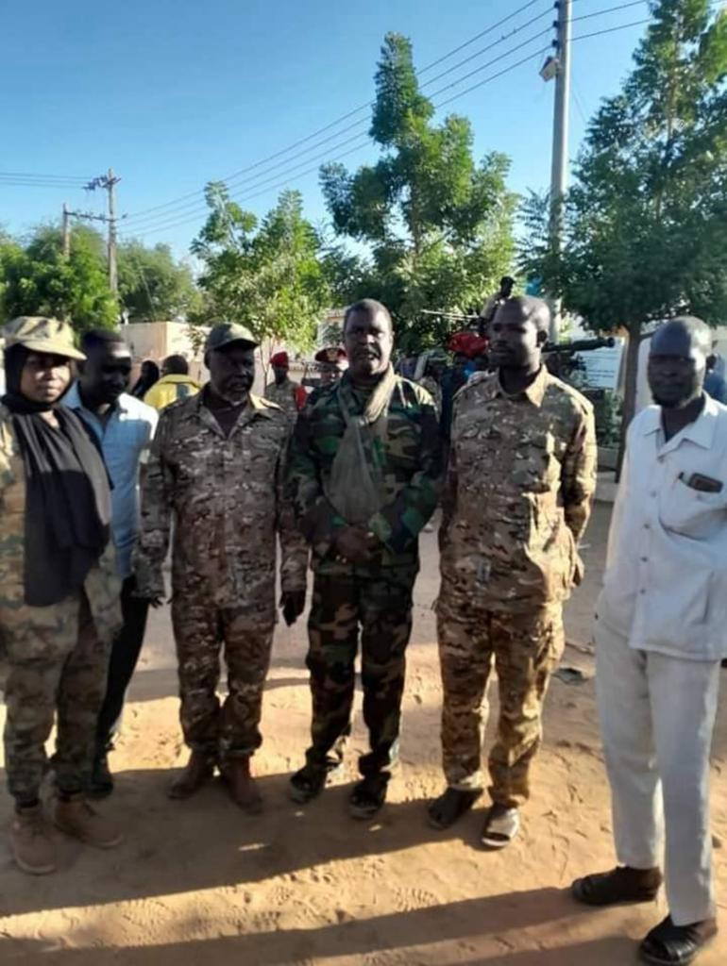

Karjakola, Sudanese Armed Forces Lieutenant-Colonel Al-Sadiq Foka and Deputy Chair of the Sudan Liberation Movement/Army-Transitional Council, Salah Adam Tor “Rasas”, in El Fasher, 24 November 2023.
Source: Panel of Experts source in El Fasher.
17. However, local tensions increased in late August regarding the issue of the humanitarian convoys escorted by Juba Agreement for Peace in the Sudan signatory movements from Port Sudan to El Fasher. RSF accused the armed groups of using those convoys to provide military supplies to SAF in Darfur. The situation was further complicated by Minawi’s meeting with General al-Burhan in Port Sudan on 3 September, contributing to growing mistrust between Minawi and RSF.
18. Tensions increased further in October, when RSF, following Nyala’s takeover, amassed forces around El Fasher under the command of Abdelrahim Dagalo, threatening to attack the SAF military base and take over the city. SAF responded with air strikes targeting RSF positions on 31 October and 1 November. The declaration of support for SAF by some Juba Agreement for Peace in the Sudan signatories heightened tensions further, but negotiations on the ground between RSF and the movements cooled the situation down.

III. Ethnically based recruitment: “militianization” dynamics

19. Since late 2022, tensions between SAF and RSF had been building, exacerbated by the political discussions concerning the framework agreement. Since then, both sides have been preparing for the worst by engaging in extensive ethnic-based recruitments in Darfur. Both warring parties continued and intensified the recruitment drive after war had broken out. They also relied on local armed militias assembled at a community level, which they mobilized, logistically supported and used as auxiliary forces. Such action accelerated the “militianization” of Darfurian society and the dissemination of weapons within communities. These factors will likely further destabilize the region.

A. Preparation for the war

1. Sudanese Armed Forces

20. In the months leading up to the conflict, SAF sought to forge alliances with traditional chiefs from non-Arab Darfuri communities. It targeted in particular those that faced confronted ongoing issues with Arabs and RSF, such as the Fur and Masalit. SAF attempted to bolster its forces with their support.
21. In February 2023, General al-Burhan and other high-ranking officers held meetings in Khartoum with high-level native leaders from the Fur community, as confirmed by various Fur leaders involved in the meetings. During the discussions, an understanding was reached, wherein SAF would recruit several thousand Fur young persons to be deployed in Fur areas within Darfur, serving as protection for the Fur community, implicitly against Arabs and RSF. Subsequent to that agreement, native Fur leaders began to compile lists of community members, including former SLA/AW fighters, who were to train with SAF. However, that recruitment process had not been completed by the time the war started and subsequently came to a halt.
22. As tensions between SAF and RSF escalated in the months preceding the conflict, SAF sought to recruit former members of Musa Hilal’s dissolved border guards force, which had been integrated into RSF in 2017. SAF also considered reforming the border guards force. Meetings were held between Hilal and SAF leaders, including General Hassan Bilal, deputy director of military intelligence, to explore such possibilities. Utilizing former border guard officers such as Musa Omer Hilal, Hilal’s nephew, SAF assembled several hundred fighters in Gadeed el-Sayl (near El Fasher) and Dawmayah (near Nyala) in March 2023 for military training. Most recruits hailed from Hilal’s Mahamid clan of the Rizeigat community, as SAF capitalized on the personal rivalry between Hilal and Hemedti, the latter from the Mahariyah clan of Rizeigat. A few hundred of those recruits supported SAF in North Darfur, engaging in clashes against RSF in El Fasher and Kabkabiyah. Hilal’s recruitment efforts were thwarted by the limited financial resources of SAF, according to sources in his Sudanese Revolutionary Awakening Council (SRAC) group.

2. Rapid Support Forces

23. At the beginning of 2023, RSF launched a large-scale recruitment campaign in Darfur, with a focus on South and West Darfur, in particular among local Arab communities (see sects. VI and VII below).

B. Ongoing recruitment

24. Recruitment drives by the two warring parties intensified after war had broken out. They were ongoing at the time of writing.

1. Sudanese Armed Forces

25. In order to match the RSF surge in Darfur since August, SAF has increased its efforts to recruit new fighters and auxiliary forces. In North Darfur, SAF used JEM/ Dabajo, a former rebel group that signed the Doha Document for Peace in Darfur in 2013 and was subsequently integrated into SAF, to recruit from the Zaghawa community. After the head of the movement, Bakhit Dabajo, himself an SAF Major-General, travelled to Port Sudan and met General al-Burhan early in September, the SAF 16th Division, based in El Fasher, recruited and graduated some 4,000 fighters. Many of these were recruited through JEM/Dabajo networks, according to sources in the group. The recruitment effort capitalized on the antagonism between the Zaghawa community and Arabs, which escalated following threats by RSF to take control of North Darfur, which the Zaghawa consider their stronghold.
26. According to various sources in North Darfur, SAF also garnered support from some paramilitary forces formed during the regime of the former President of the Sudan, Omar Al-Bashir. In particular, in El Fasher, it coordinated with elements of the Popular Defence Forces who were recruited by Osman Kibir from his Berti community when he was Governor of North Darfur (2011–2015). These elements are known as “Kibir’s militia”.
27. Following the events in El Geneina in June, there was a rapprochement between SAF and representatives of the Masalit community. Several native, political and military leaders of the community, including Masalit leaders of the SA armed group, visited Port Sudan, where they had meetings with SAF representatives and government authorities to discuss military cooperation against RSF and the recruitment of Masalit into SAF. However, mobilizing or supporting armed Masalit in eastern Chad appeared very complicated to SAF, which did not have access to Chad. Instead, SAF focused on recruiting within the Masalit community of Gedaref State (east Sudan).

2. Rapid Support Forces

28. The war crystallized a feeling of common Arab identity among Arab communities of Darfur (and Kordofan), temporarily suspending old internal rivalries such as the tensions between Mahamid and Mahariyah, and members of those communities coalesced in large part in support of RSF. On the basis of Arab solidarity and substantive financial means, RSF attracted various Arab armed groups and militias, including former foes.
29. In its military operations in Darfur and Khartoum, RSF had an increasingly heavy reliance on those new allies. In particular, several former commanders and dissident groups formerly aligned with the RSF rival, Musa Hilal, played a major role in the RSF military campaign. For example, Abdallah Hissene and Mohamed Khadam, two former Hilal leaders in Libya who joined RSF in 2022, as well as Ali Rizgallah “Safana”, a well-known former Arab rebel leader and Hilal ally, now play a key role in RSF operations. Early in September, a force constituted of several hundred fighters from various Hilal splinter groups, such as SRAC/Democratic and SRAC/Collective Leadership, arrived in Darfur from Libya. They now operate under the RSF banner in Khartoum, according to multiple sources in those groups.
30. Several commanders and factions of the Third Front-Tamazuj, a group initially closer to SAF, have also joined RSF since the beginning of the fighting. These include Ahmed Adam Gouja, formerly involved in incidents against the authorities in West Darfur in 2021 and 2022. In August, the head of one of the leading Third Front-Tamazuj groups, Mohamed Ali Gurashi, himself a Rizeigat from East Darfur and previously an SAF supporter, announced his support for RSF. Among the Arab factions of the SA armed group, most of the key leaders and commanders, such as Saad Mahil, also joined RSF.

C. Proliferation of small and light weapons as a result of the “militianization” process

31. The above-mentioned process fuelled the large-scale proliferation of small and light weapons in Darfur. The belligerents provided weapons to the civilians supporting them, RSF to local Arab communities in particular, but also, to a lesser extent, police to Masalit in El Geneina. During the clashes, local militias looted the arms stores of police stations, such as in Nyala. The “militianization” process, in particular the distribution of weapons to local communities, fuelled an escalation in violence in several localities.
32. From June, many RSF soldiers fighting in Khartoum, in particular among those recruited in Darfur just before the conflict, began to return to their communities. They brought goods looted in Khartoum and their weapons, in contravention of the current arms embargo. Armed Arabs, including RSF returnees and defectors, were then selling some of their weapons in open markets around main cities such as Nyala and El Geneina. According to local sources, assault rifles such as AK-47s were available for sale in those markets for approximately $830, while heavier machine guns such as 12.7mm ones were available for approximately $3,300.

D. Fragmented command and control

33. The warring parties’ overreliance on independent commanders who just joined them without proper integration and training, or on new fighters recruited through ethnic networks, generated a weakening of their chain of command, with some new local commanders and forces acting independently and in pursuit of their own agenda. A resulting lack of discipline and of internal cohesion frequently undermined SAF and RSF military activities. For example, in El Fasher, in late October, Musa Hilal fighters stopped supporting SAF and left the latter’s military base, following separate negotiations with RSF. Within RSF, the Panel was informed of several cases in which new field commanders refused to follow the leadership’s orders.
34. The reliance by RSF on ethnically based recruitment fuelled intercommunal violence among Arab communities. This was illustrated by the clashes between the Salamat and Beni Halba and the Salamat and Habbaniyah. Early in August, conflict erupted in Kubum, 136 km west of Nyala, between the Beni Halba and Salamat communities that had previously contributed to RSF recruitment efforts in South Darfur. Members of both groups employed RSF-provided military equipment during the fighting. Furthermore, the Panel received reliable accounts of RSF personnel leaving Khartoum, Nyala and Zalingei, armed and equipped with ammunition, to fight with their people in that area. Clashes between the Salamat and Beni Halba lasted until November. In November, a separate conflict between the Salamat and the Habbaniyah erupted. Salamat fighters accused the Habbaniyah of being aligned with SAF. The clashes, which took place mostly in Buram area (South Darfur), resulted in widespread displacement, with approximately 6,000 households seeking refuge in Buram town and neighbouring areas.

IV. Weapons supply for the Sudanese Armed Forces and the Rapid Support Forces in Darfur

35. In the initial phase of the clashes in Darfur (April to July 2023), the advanced military equipment and weapons observed in Khartoum (Sukhoi 25, Mig 29 and Mig 24 aircraft, attack helicopters, man-portable air defence systems and combat drones) were not seen in Darfur. The various forces (SAF, RSF, Juba Agreement for Peace in the Sudan signatory groups and militias) used the easily available weapons and military equipment: 12.7mm and 14.5mm heavy machine guns, as well as ZU23 anti-aircraft guns, mounted on Landcruiser vehicles; rocket-propelled grenades; mortar guns; various types of rocket launchers; Soviet-era BTR 80 armoured personnel carriers; and various types of small and light weapons.
36. However, since August the renewed military campaign of RSF to take control of the main cities of Darfur resulted in an escalation of military means used by both sides. The RSF surge coincided with it securing new supply routes (see paras. 38–49 below).

A. Offensive military overflights

37. Since August, SAF responded to the RSF surge in Darfur with offensive military overflights, an action prohibited by the sanctions regime. On several occasions, SAF conducted airstrikes on RSF positions, with aircraft flying from military airports outside Darfur. For example, SAF claimed responsibility for airstrikes on 28 and 29 August on the RSF base of Zuruk (North Darfur). Since August, according to various witnesses, media reports and videos, SAF has also conducted several airstrikes on RSF forces in the Nyala, Ed Daein and El Fasher areas, sometimes using their Antonov An-32 fleet (see sect. VII below).

B. New supply lines

38. Since the outbreak of the war, SAF garrisons in Darfur have not been able to be replenished with any meaningful military supplies, given that RSF took swift control of most portions of the road between Kusti and El Fasher, the main supply route of SAF from Khartoum and Port Sudan to Darfur. Early in September, some RSF members and sympathizers accused SAF of bringing military supplies to its El Fasher military base by using the humanitarian convoys coming from Port Sudan, in collusion with the armed movements escorting the convoys, SLA/MM in particular. While several Panel sources in the movements acknowledged that this was likely, the supplies were too few and limited to alter the conflict dynamics.
39. On the other hand, since the beginning of the war, in particular since July, RSF was able to secure new supply lines to and through Darfur for weapons, vehicles and logistics. According to eyewitnesses and videos, in its increased military campaign in Darfur since August, RSF has used several types of heavy and/or sophisticated weapons that it was not using there before. This included unmanned combat aerial vehicles, howitzers, multiple-rocket launchers and anti-aircraft weapons such as man-portable air defence systems, observed in Nyala, El Fasher and El Geneina.
40. This new RSF firepower had a massive impact on the balance of forces on the ground, both in Darfur and in other regions. New RSF heavy artillery items played a major role in its capture of Nyala and El Geneina (see sects. VI and VII below), according to various local sources, including in SAF, while new anti-aircraft devices helped RSF to counter the main asset of SAF, its air force. For example, in October, according to official statements, various local sources and videos, RSF shot down an SAF Antonov in the Nyala area. In a video of the RSF crew who shot down the aircraft, the Panel identified a man-portable air defence systems, likely a SA-7 type.

C. New supply lines of the Rapid Support Forces

41. The Panel identified three main routes, still active to date, for RSF supplies. The main one was through eastern Chad. Since June, various flight-tracking experts have observed a heavy rotation of cargo planes coming from Abu Dhabi International Airport to Am Djarass airport in eastern Chad, with stops in regional countries such as Kenya, Rwanda and Uganda. Several media reports claimed that the aircraft were transporting weapons, ammunition and medical equipment for RSF. On 28 November 2023, the SAF Lieutenant-General and Sovereignty Council member, Yasir al-Atta, made similar claims, accusing Chad and the United Arab Emirates of providing military support to RSF through Am Djarass. The United Arab Emirates responded to those allegations by stating that the cargo planes had a humanitarian purpose, in particular to establish a field hospital in Am Djarass for Sudanese refugees.
42. According to information gathered by the Panel from sources in Chad and Darfur, the allegations were credible. Several sources in eastern Chad and Darfur, including among local native and administrative leaders and armed groups operating in those areas, reported to the Panel that, several times per week, weapons and ammunition shipments were unloaded from cargo planes arriving at Am Djarass airport, then loaded on trucks. Small convoys, comprising one to three trucks escorted by an armed Landcruiser, left the airport through the western gate and reached the Darfur border, through Bao or Kariari, where shipments were handed over to RSF, which transported the shipments to its base in Zuruk (Umm Barru locality, North Darfur). Some weapons were distributed to RSF positions in Darfur, while most of them were transported from Zuruk to Khartoum through desert roads in a north-east direction usually used by smugglers. The Panel wrote to the Permanent Representatives of Chad and of the United Arab Emirates to the United Nations on 14 December 2023, sharing its findings. In its response, dated 21 December 2023, the United Arab Emirates denied any involvement in the shipment of arms and ammunition from the United Arab Emirates to RSF through Chad. It also noted that the flights from the United Arab Emirates transported humanitarian assistance (see annex 5 to the present report). As at 22 December 2023, the Panel had yet to receive a response from Chad.
43. Several RSF field commanders, chosen for their knowledge of the border area and desert routes, oversaw the supervision of the transportation of the weapons into Darfur and the Sudan. They included a former SLA/MM field commander who joined RSF in 2014, Abdallah Chagab, now one of the RSF field commanders in Khartoum North, from the Zaghawa community. These large-scale and sustained supplies ranged from small and lights weapons to unmanned combat aerial vehicles, anti-aircraft missiles, mortars and various types of ammunition.
44. According to various sources, in particular among members of southern Libyan communities such as Tebu and Darfurian armed groups based in Libya, RSF used another supply route into Darfur, from southern Libya. RSF procured substantial quantities of fuel from there. Some elements of the Darfurian armed movements in Libya, who had facilities to buy fuel at cheaper rates thanks to their relations with the Libyan National Army (LNA), played a leading role in that smuggling. Tanker trucks belonging to the movements and escorted by some of their elements transported the fuel to RSF in North Darfur through the Libya-Chad-Sudan tri-border area, often through Am Djarass.
45. RSF also purchased cars from Libya, in particular Landcruisers, which, such as fuel, were essential to their military tactics based on mobility and pace. For example, the Panel was aware of a case in September when RSF imported several dozen new cars from southern Libya. Cars were gathered in Sabba, then were brought in Darfur to Zuruk by drivers hired by RSF, through Kufra. In another case, when they returned from Libya to the Sudan through Darfur to join RSF in mid-2023, Hilal splinter groups came with several dozen new Landcruisers, purchased for them by RSF, according to members of those groups.
46. RSF was also able to procure weapons through Libya. For example, the Panel was aware that, during the first weeks of the conflict, RSF asked for the cooperation of a Darfurian armed movement based in Libya in transporting artillery items and ammunition obtained in Libya to Darfur, proposing in return to give a share of the equipment to the movement. While the movement’s field commanders were in favour of that deal, it did not happen because the head of the movement vetoed it.
47. In the operations from Libya, RSF benefited from coordination with several LNA brigades based in southern Libya. These included Subul al-Salam, a predominantly Zuwaya, Salafist brigade based in Kufra and controlling the border with the Sudan, with whom some RSF forces were already cooperating for smuggling activities before the war. According to various Libyan sources, Subul al-Salam was instrumental in facilitating the replenishment of RSF with fuel, cars and ammunition. The 128 Brigade, which had a presence in southern localities such as Sabba and was the main Libyan partner of Darfurian armed movements, was also involved.
48. Lastly, RSF secured a supply route from South Sudan for fuel. Trucks carrying fuel moved from Juba to Wau on a weekly basis. From Wau, fuel was transported in civilian cars such as Landcruisers to Raja, then to RSF-controlled areas in South Darfur, through Kafia-Kingi. While local South Sudanese officers, such as some army officers in Wau, were involved in the smuggling, South Sudanese government authorities did not play any role.
49. The Panel notes that the transfers of arms and ammunition into Darfur constituted violations of the arms embargo.

D. Arms from the Central African Republic

50. According to multiple sources in the Sudan and the Central African Republic, RSF acquired weapons and ammunition in north-eastern Central African Republic on two occasions during the first weeks of the conflict. The first transaction occurred on 28 April 2023, when three RSF vehicles travelled from the Am Dafok area, the Sudan, to Birao, Central African Republic, where they received the first batch of weapons. A similar transaction took place on 3 May, approximately 25 km east of Birao, in Terfélé (Central African Republic). The Sudanese authorities in Bangui had raised the issue with the Government of the Central African Republic after the first transaction, which may explain the shift to a more discreet location for the second delivery.
51. According to multiple military sources, those weapons included man-portable air defence systems and associated ammunition that RSF sought to acquire to counter the SAF air force. Subsequently, RSF transported those military supplies from the Central African Republic to South Darfur, passing through the Am Dafok region, before they ultimately reached Khartoum.
52. The operations were coordinated and executed by the RSF commander, Abdallah al-Jazouli, operating from the Am Dafok region. Prior to his affiliation with RSF early in 2023, al-Jazouli, a member of the Taisha community, had an extensive history as an active arms smuggler in the border area. He was known for supplying weapons to various Central African Republic rebel groups. Moreover, al-Jazouli had maintained favourable business relations with the Sultan of Kara, who is based in the town of Terfélé. By engaging in those arms acquisitions and transportation, RSF violated the arms embargo.

V. Humanitarian crisis and international humanitarian law violations

A. Overview

53. According to the Office for the Coordination of Humanitarian Affairs, and as at 7 December, an estimated 12,000 people had been killed since the beginning of the conflict in the Sudan. The conflict caused a large-scale humanitarian crisis and displaced approximately 6.8 million people (5.4 million internally displaced persons and 1.4 million refugees).
54. In Darfur, the violence intensified, in particular in urban areas, which had a severe impact on civilians. According to intelligence sources, between 10,000 and 15,000 people were killed in El Geneina alone. With approximately 4.7 million internally displaced persons, 1.7 million people were displaced for the first time and many of the already existing 3 million internally displaced persons were displaced a second or a third time. The conflict was a main driver of food insecurity, with more than half of the population in Darfur facing acute hunger. The violence had a specific impact on women and children who were subject to increased sexual violence and other violations, including child rights violations.
55. Overall, the conflict caused more than 1.4 million people in the Sudan to flee to neighbouring countries, more than half of them to countries neighbouring Darfur. Approximately 555,000 fled the violence in West Darfur, crossing the border to Chad, where the situation was precarious, given that humanitarian assistance was lacking the funding necessary to respond to soaring needs. In addition, many took perilous journeys through East Darfur to reach South Sudan for refuge.

B. Violations of international humanitarian law by the warring parties

56. Disproportionate and indiscriminate attacks on civilians, mistreatment of civilians (torture, rape, killing, mass arrests and detentions), forced displacement, pillaging and destruction of critical civilian infrastructure, including humanitarian assets and attacks on personnel, constituted war crimes under the Geneva Conventions of 1949 and customary humanitarian law. Some of those violations may have amounted to crimes against humanity.

1. Indiscriminate shelling and aerial bombing in highly populated areas, attacks on critical civilian infrastructure and pillaging

57. SAF and RSF used heavy artillery and shelling indiscriminately in highly populated areas, severely affecting civilians in El Geneina, Nyala, Zalingei and Ed Daein (see sects. VI and VII). SAF used aerial bombings in urban areas in El Fasher, Nyala and Ed Daein. The shelling by both parties caused the widespread destruction of critical civilian infrastructure necessary for basic services, including water, sanitation, health care and education. Schools, hospitals, markets, government buildings and humanitarian assets were looted mostly by RSF and allied militias and destroyed by shelling and bombing by the two warring parties (see annexes 2–4 to the present report for satellite images of the destruction in Nyala, Zalingei and El Geneina).

2. New displacement and violence against camps for internally displaced persons

58. Camps for internally displaced persons in West, South and Central Darfur, many reliant on humanitarian aid previous to the conflict, were attacked and confined, aggravating the lack of access to medical care, water and food. Since the beginning of the conflict, internally displaced persons in Zalingei’s Hasahisa camp, where the Fur community represented the majority, have been caught between RSF and SAF crossfire, causing deaths and injuries. Local sources reported that young men were stopped at RSF-controlled checkpoints and denied access to other areas because they were suspected of joining SAF. Lastly, on 31 October, when RSF took over the SAF base in Zalingei, at least 16.250 internally displaced persons were violently displaced from the camp. The Panel received reports from local monitors of the rape of 24 women by RSF (see annex 2 to the present report for maps and satellite images showing the impact and destruction of Hasahisa camp).
59. By October, the Kalma internally displaced persons camp (Nyala) became severely overcrowded, housing up to 500,000 internally displaced persons who had fled the violence in Nyala. Internally displaced persons reported that the camp was under siege by RSF, that they were robbed and prevented from leaving, while also being arbitrarily detained at RSF-controlled checkpoints when attempting to leave. Women were subjected to sexual violence. There was a critical lack of food.
60. According to local sources, 80,000 internally displaced persons, mostly women and children who were displaced from the north of El Fasher, Nyala, Zalingei, El Geneina, Tawilah and Kutum, found shelter in El Fasher in overcrowded school buildings or were left in the open. Internally displaced persons were in vulnerable condition, with acute health-care and food needs.

3. Widespread harassment, arbitrary arrests, detentions, torture and ransom for release

61. The Panel received reports of widespread harassment, physical abuse, arbitrary arrests and detention, torture and killings by RSF and allied militias targeting community leaders, lawyers, journalists, resistance committee members and human rights activists. The targeting was due primarily to the work that they performed before and during the conflict as they continued to monitor, report on and advocate against violations committed by the warring parties.
62. For example, the Darfur Bar Association reported to the Panel that more than 20 colleagues had been threatened, 16 members arbitrarily detained and tortured and 7 killed by RSF and allied militias. In addition, the Panel documented at least 10 cases in which prominent female human rights activists, lawyers and journalists in El Fasher, El Geneina and Nyala were harassed and physically abused, with some threatened with rape or killed by RSF and allied militias. Furthermore, women interviewed by the Panel reported being threatened by SAF in Nyala and El Fasher owing to their monitoring activities. Although many fled from Darfur fearing for their lives, they continued to receive threats. For example, in El Fasher a prominent female lawyer was threatened, arbitrarily detained and tortured twice by RSF. Although she fled the Sudan, she continued to receive threats. Similarly, SAF arbitrarily detained and interrogated a prominent female journalist in El Fasher.
63. Similarly, RSF and, sometimes, SAF harassed, arbitrarily arrested, detained and tortured civilians in El Fasher, Zalingei, Nyala and El Geneina on suspicion that they were ethnically aligned with the opposing warring party. This affected both Arab and African communities. For example, an Arab aid worker in El Fasher was continuously harassed by SAF, which accused him of aligning with RSF owing to his ethnicity. He was arbitrarily arrested, detained and interrogated, following which he fled the city.
64. RSF commonly demanded ransom for the release of those whom they detained. The Panel received information of at least nine cases in Murnei (West Darfur) of individuals who were detained upon suspicion of supporting SAF. Most of those released had to pay a ransom. In Nyala, RSF and allied militias kidnapped a prominent lawyer and demanded a large ransom for his release. The lawyer was subsequently killed and left by a road, his body found with signs of torture.

4. Conflict-related sexual violence

65. The escalation of the conflict exposed women and girls to increased risks of sexual violence. Sexual violence not only was widespread, but also escalated across Darfur as the conflict progressed. The Panel interviewed reliable sexual and gender-based violence local monitors who reported 262 rape cases over the period from April to August. The figures were likely to be much higher owing to underreporting, the overall lack of access to health care, lack of Internet connectivity and the fear of stigma and marginalization from the victims’ communities.
66. Widespread sexual violence committed by members of RSF and allied militias were reported in all areas under RSF control. Women and girls aged 9 to 75 were at risk of being raped in camps for internally displaced persons, when traveling, at checkpoints and in their homes. Racial slurs were common during the violations. In El Geneina, women were targeted owing to their Masalit ethnicity (see sect. VI below). In Nyala, almost all the cases of sexual violence occurred in camps for internally displaced persons and in neighbourhoods inhabited by African communities. Similar patterns were observed in Zalingei and El Fasher.
67. Kidnapping, ransom and sexual exploitation formed part of the conflict-related sexual violence patterns. For example, reliable local sources reported at least 25 cases of kidnapping, rape and sexual exploitation at the RSF-controlled Aldaman hotel in Nyala. In El Geneina, the Panel received reports of 16 girls having been kidnapped and raped by multiple men in an RSF house (see sect. VI below).

5. Violations of child rights, recruitment and use of children

68. The escalation of conflict in Darfur exposed children to increased risks of sexual violence, killings and mass forced displacement. Schools were looted, occupied or destroyed, while access to humanitarian aid was limited. Furthermore, the Panel received information on the recruitment and use of children by the two warring parties. Local sources confirmed seeing children in the ranks of RSF and SAF, including in recruitment camps, in El Fasher, Zalingei and Nyala. The Panel’s sources reported that Arab community leaders recruited boys into RSF. Some mentioned that boys singed up themselves at recruitment centres in the cities. In Nyala, according to local sources, new underaged recruits were promised sums between 200,000 and 500,000 Sudanese pounds and looting gains.

VI. Case study 1: ethnically targeted violence in El Geneina and Ardamatta

A. Overview

69. Between 24 April and 19 June, the city of El Geneina in West Darfur underwent a period of intense violence. This was followed by the takeover of the SAF 15th Division in Ardamatta on 4 November by RSF. Historic ethnic tensions between communities were orchestrated by prominent military, political and traditional leaders for their own political and economic gain. RSF and allied militias deliberately targeted civilian neighbourhoods, gathering sites and camps for internally displaced persons, schools, mosques and hospitals, while looting homes, international non-governmental organizations and United Nations compounds. Furthermore, they deliberately rendered useless water pumps that were vital for the survival of the community. RSF and allied militias targeted the Masalit community deliberately.
70. The cycle of violence had nine distinct phases (see table 2). Throughout the phases, the intensity of the violence fluctuated between two main patterns: large-scale, coordinated attacks by RSF employing heavy artillery in civilian neighbourhoods, targeting primarily the southern part of the city where the majority of the Masalit community resided (phases 1, 3 and 5); and periods of relative calm (phases 2 and 4), during which RSF with allied militias engaged primarily in activities such as resupplying (often through looting), mobilizing forces, establishing checkpoints to confine the population, targeting prominent leaders of the Masalit community, and strategically placing snipers throughout the city to limit people’s movement (see annex 1 to the present report for arms and ammunition used during the violence in El Geneina).
71. The wave of attacks reached its peak with the siege of the city and the killing of Abakarthe Wali of West Darfur, Khamis Abdallah Abakar, who was last seen with the RSF West Darfur commander, General Abdel-Rahman Juma Barktallah, on 14 June (phase 6). Consequently, a mass forced displacement took place from El Geneina to Adré, Chad, and Ardamatta, located 6 km north-west of El Geneina, where SAF headquarters were situated (phase 7). The most recent wave of violence occurred between 1 and 3 November (phase 8), which culminated with the takeover of the SAF 15th Division in Ardamatta on 4 November (phase 9).
72. During phases 1 to 7, SAF remained confined within its barracks, with some of its forces stationed near the Wali’s home. Throughout the attacks, it failed to protect the population. Moreover, after the execution of the Wali on 14 June, the forces stationed around his house left the city and returned to their barracks in Ardamatta. Meanwhile, the signatory group to the Juba Agreement for Peace in the Sudan, SA, faced challenges in mounting an organized military strategy to repel the attacks owing to a lack of ammunition. Consequently, SA members resorted to individual resistance within their relevant neighbourhoods, with some strategically positioned at locations such as the Wali’s office and residence.
73. In the absence of any protection, self-defence groups of Masalit, which were established after the Krinding I attacks in late December 2019, took on the responsibility to protect the population. With insufficient military training and possessing inferior equipment, consisting primarily of light weapons, they were at a considerable disadvantage and unable to mount an effective response against the aggression.
74. On 1 November, RSF initiated attacks on the Ardamatta SAF 15th Division, besieging both civilians and soldiers. Ardamatta was the last bastion of SAF in West Darfur and the only place in El Geneina hosting the Masalit population after the events of June.
75. Between 1 and 3 November, RSF and allied militias attacked Ardamatta and fought SAF soldiers, some GSLF fighters who joined SAF headquarters in May, members of the SA and Masalit self-defence groups. On 3 November, several members of SAF fled to Sulay‘ah, Jebel Moon. On 4 November, remaining SAF soldiers, Masalit self-defence group members and SA fighters withdrew towards Chad, where approximately 60 vehicles entered, surrendering their arms and ammunition to the Chadian authorities. On the same day, RSF seized control of the SAF 15th Division, captured Ardamatta and detained numerous fighters and civilians (see paras. 98–100 below). RSF arrests included the head of SAF military intelligence in El Geneina, Al-Walid Ataullah, accused by RSF of igniting intercommunal clashes in El Geneina by distributing arms and ammunition to the various local communities.
76. After capturing Ardamatta, RSF released a video on X (formerly Twitter) of its de facto Wali, Tijani Karshoum, walking with the community in the area and participating in cleaning efforts. On 17 November, General Abdel-Rahman Juma Barktallah sent televised instructions to his soldiers to uphold the rule of law, protect citizens and facilitate the safe delivery of humanitarian aid from Chad.

Table 2

Phases of the conflict in El Geneina and Ardamatta

Phase | Date | Main action
1 | 24–27 April | Initial SAF-RSF clashes. Fighting spread to the southern neighbourhoods. RSF used heavy artillery in Masalit areas, including Al Jabal and gathering sites for internally displaced persons
2 | 28 April–11 May | RSF resupplied and assembled soldiers and Arab allied militias inside and around the city, preparing for the next offensive. RSF targeted prominent Masalit leaders
3 | 12–26 May | RSF and allied militias resumed attacks with heavy artillery in Masalit-populated neighbourhoods and camps and gathering sites for internally displaced persons
4 | 27 May–5 June | RSF resumed the resupplying and assembly of allied militias. RSF targeted Masalit individuals. RSF placed new snippers in the city to confine the population
5 | 6–13 June | RSF launched coordinated attacks with heavy artillery in Masalit neighbourhoods, including new and old gathering sites for internally displaced persons and the surrounding areas of the residency of the Wali
6 | 14 June | Killing of the Wali of West Darfur
7 | 15–19 June | Mass forced displacement from El Geneina to Adré and Ardamatta. RSF targeted fleeing Masalit communities
8 | 1–3 November | RSF attacked Ardamatta and targeted Masalit who fled for refuge and prominent Masalit leaders
9 | 4 November | RSF took over the SAF 15th Division headquarters

B. Coordination between military, political and native leaders

77. The attacks were planned, coordinated and executed by RSF and their allied Arab militias. The leaders of the Arab communities who were facilitating and coordinating the attack with RSF to El Geneina included Amir Masar Abdurahman Aseel (a leader of the Mahamid community based in the western outskirts of El Geneina) and Tijani Karshoum (also from the Mahamid community, based in Al Jabal, a member of Juba Agreement for Peace in the Sudan signatory movement, GSLF, and who was appointed as deputy Governor in July 2022).
78. Amir Masar and Karshoum facilitated the recruitment of militias to fight alongside RSF with a number of other local Arab leaders, including Agid Ismail al-Bideri (from the Maharyiah community), Amir Hafiz Hassan (from the Misseriya) and Amir Hamid Dawai (a leader of the Awlad Rashid community). In January, several of those leaders met RSF leadership in Khartoum and, in exchange for money, recruited members of their communities. The largest mobilization within El Geneina took place weeks before 15 April, when clashes in Khartoum commenced, and carried on until 24 April (phase 1 of the conflict). The militias were assembled in various areas in El Geneina and surrounding areas. These included Jabal (on Karshoum’s block) and Wadi Rati (south), Rigil al-Kubri (west), Um Al-Qura (north) and Um Duwaym (east). In addition, militias were also gathered in Masar’s area, Kaskidik, Kurti, Umm Sidera, Dula Laham, Adar and Sukri. Throughout the conflict, those sites continued to serve as assembly places for the militias.
79. RSF established local headquarters in neighbourhoods that served as operational centres. Masar frequently visited some of those headquarters, distributing weapons and coordinating with RSF-allied militias. In addition, allied militias established their own operational centres, which were frequently visited by RSF officers for coordination purposes. The largest of those centres was located in the building of the former Ministry of Animal Resources, while others were in the Nasaim area, Arbukni, an area known as water point 13, and Abdala Abdala school.
80. The coordination between RSF and allied militias went well beyond the boundaries of the city. The road between El Geneina and Adré (Chad) was under the coordinated control of RSF and allied militias. Mohamed Bashir was in charge and coordinated the deployment of mixed forces (RSF-allied militias) at each checkpoint (the number of checkpoints fluctuated between nine and three, depending on the day) with Agids. They also cooperated regarding the safe passage procedures. For example, the Agid in control of Adikong area (the border area between Chad and the Sudan), Anur Fayea Abouda (Mahamid community), attended, with Bashir, the local negotiations for the opening of border between Chad and the Sudan.
81. It is important to note that not all members of the Arab communities were involved in the violence and that many actively protected the Masalit people. Masalit individuals found refuge in the homes of their Arab neighbours, who assisted them in escaping to Adré. Many Masalit leaders expressed gratitude for being released on the basis of assurances and declarations of innocence from their Arab neighbours.

C. Governance vacuum in El Geneina

82. After the fall of El Geneina on 14 June, a governance vacuum ensued. Tijani Karshoum tried to capture the space and create an appearance of governance, while coordinating with RSF and influential local Arab militia leaders. That de facto administration engaged, for example, in negotiations with United Nations humanitarian agencies and international non-governmental organizations for the delivery of humanitarian aid, which, at the time of writing, had been limited and focused primarily on local Arab communities. However, by November, traditional Arab leaders were each controlling their own territories, paying little to no attention to Karshoum’s administration. Meanwhile, General Abdel-Rahman Juma Barktalla, who had left El Geneina at the beginning of August, fought in Zalingei and returned days before the attack on Ardamatta, established his base in the vicinity of El Geneina airport and was appointed by Abdelrahim Dagalo as commander of the 15th Division.

D. Violations of international humanitarian law

83. The Panel collected evidence and testimonies from more than 120 interviews with victims and eyewitnesses who consistently reported that RSF and allied militias had committed violations of international humanitarian law. The conflict led to ethnically motivated and forced mass displacement, with an estimated 555,000 individuals arriving in Chad since the beginning of the conflict.
84. On 15 June, RSF, in a public statement, denied any involvement in those violations and called for an independent investigation. In a voice recording on 19 June, the RSF commander in West Darfur, General Abdel-Rahman Juma Barktallah, denied RSF involvement in the violence; instead, he blamed SAF for instigating tensions between the local communities and uncontrolled outlaws for the attacks on the Masalit, including the killing of Wali Khamis Abakar. In a voice recording released on RSF social media on 20 June, Hemedti stated that an internal investigation committee would be formed and dispatched to El Geneina to collaborate with the independent investigation, if established. At the time of writing, it remained unclear whether this had taken place.

1. Conflict-related sexual violence

85. Conflict-related sexual violence committed by RSF and allied militias was widespread. Reliable local monitors reported to the Panel that, from 27 April to 29 May, 63 instances of rape had occurred in the Jabal and Madaris areas. According to this and other reliable sources from El Geneina, women and girls, some as young as 14 years old, were raped by RSF elements in World Food Programme storage facilities controlled by RSF (35 cases), in their homes or when returning to their homes to collect their belongings after being displaced by the violence. Racial slurs towards the Masalit and non-Arab community formed part of the attacks. Furthermore, the Panel received reports of 16 girls being kidnapped by RSF soldiers in Jabal and Thawrah neighbourhoods and raped in an RSF house. Owing to the lack of access to medical care, no means of communication and continued violence, those numbers were likely to be higher.

2. Systematic and widespread looting and ethnically motivated attacks

86. The systematic and widespread attacks, looting and destruction of civilian objects, including hospitals, mosques, schools, government buildings, markets, water points and humanitarian premises, prevented access to basic services. Mosques and schools that were used for shelter were attacked. Neighbourhoods and homes were continuously attacked, looted, burned and destroyed, targeting the neighbourhoods where Masalit and other African communities were harassed, physically assaulted, sexually harassed, sexually abused and, at times, executed. On a smaller scale, the Masalit communities also engaged in looting in the city centre, mainly of the international non-governmental organizations’ premises (see annex 3 to the present report for satellite images of the destruction).

3. Snipers indiscriminately targeting civilians, causing self-imposed civilian confinement

87. RSF placed snipers on the main roads who indiscriminately targeted civilians, including women, pregnant women and young people. All eyewitnesses saw many dead bodies on the roads of the city, with reports of 92 deaths and 21 injured. Although witnesses were unable to confirm total numbers of deaths, individuals reported seeing more than 13 bodies in one day. Eyewitnesses confirmed seeing bodies used as roadblocks. The threat of snipers, various RSF and militia checkpoints within the city, and the continued attacks confined neighbourhoods in the southern part of the city, in which people had limited access to food and water.

Photo 1

Scattered bodies in El Geneina, 16 June 2023
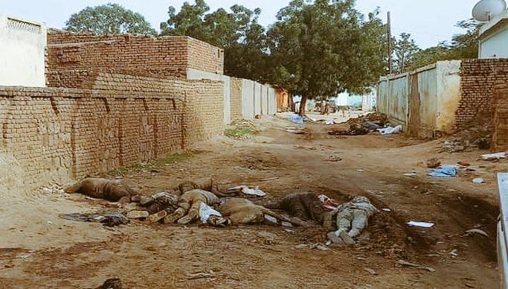

Source: Public photo, corroborated by the Panel.

4. Systematic targeting of gathering sites for internally displaced persons

88. There were 120 gathering sites for internally displaced persons in El Geneina locality, hosting more than 80,000 people, mostly Masalit, who had been displaced in previous attacks on their community. During the recent violence, those gathering sites were systematically attacked, looted, burned and destroyed. The severe and widespread attacks on those sites and neighbourhoods caused renewed displacement.
89. Civilians sought shelter in various schools and mosques, with the Azahara girls’ boarding school in Madaris becoming a large gathering site, housing an estimated 1,000 families – more than 5,000 people. Next to it, the Algadima school sheltered 3,500 families. Those sites and others were bombed with heavy artillery and mortars. On 12 June, witnesses relayed that approximately 26 bombs had hit gathering sites for internally displaced persons in one day. Although exact numbers were difficult to establish, witnesses reported significant number of deaths and injured, including women and children, some estimating between 60 and 70 casualties daily.

Photo 2

Gathering sites for internally displaced persons targeted and destroyed during the conflict in El Geneina

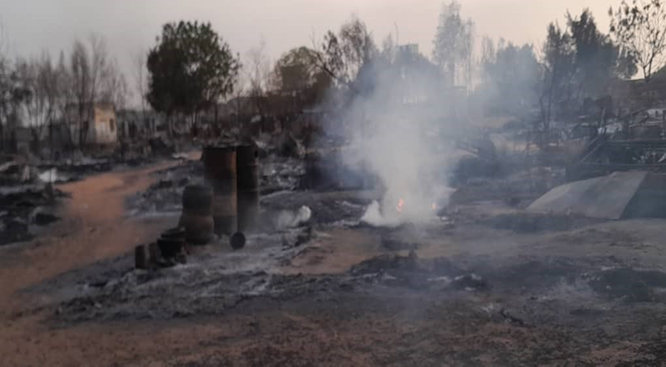
Source: Confidential.

Photo 3

Gathering sites for internally displaced persons targeted and destroyed during the conflict in El Geneina

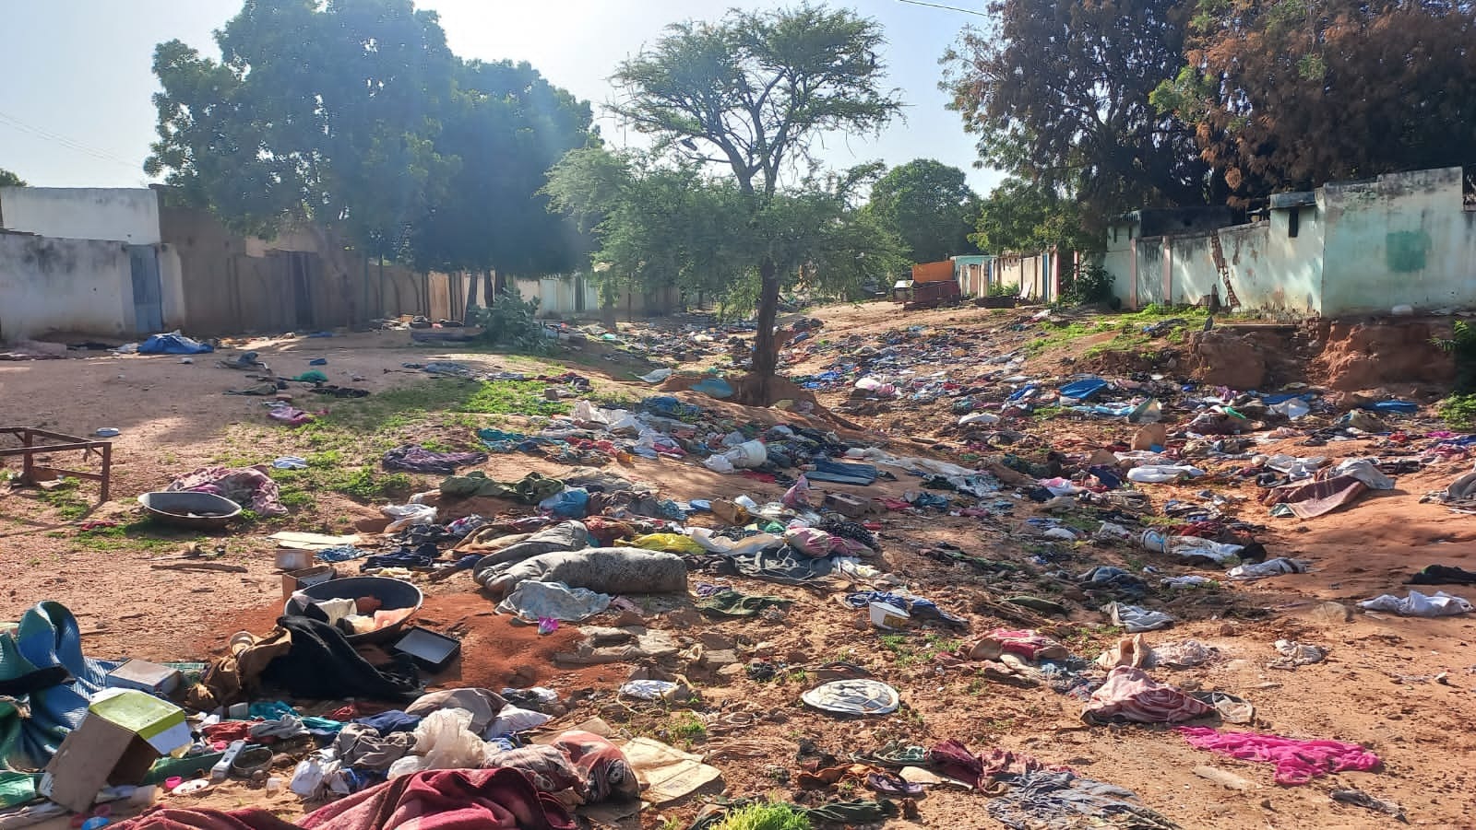

Source: Confidential.

5. Systematic ethnically motivated and targeting killings of prominent Masalit community members

90. Ethnically motivated and targeted killings in which RSF and allied militias attacked the homes of those on a list of prominent Masalit community leaders, human rights activists, lawyers, teachers and journalists were systematic. Survivors reported being targeted and threatened owing to their profession and Masalit ethnic identity. At least two prominent lawyers were directly targeted and killed by RSF and allied militias owing to their involvement in legal cases concerning previous attacks on Masalit communities. Three prominent doctors and seven staff were directly targeted and killed. Known prominent community leaders were harassed and some were executed. Human rights activists were killed while monitoring and reporting on the events.

6. Targeted attacks on hospitals and medical facilities

91. RSF and allied militias looted and destroyed all hospitals and medical storage facilities, which resulted in the collapse of health services. As a direct consequence of those attacks, 37 women with childbirth complications and 200 dialysis patients died. Furthermore, witnesses stated that some patients were executed in the clinics and that the emergency clinics were attacked. On 6 May, owing to the scarcity of medical supplies, the late Wali, Khamis Abdallah Abakar, attempted to evacuate the seriously injured to Chad. The plan fell through because RSF demanded high fees for safe passage.

7. Seeking protection at Ardamatta: forced displacement and mass killings of civilians

92. Following the killing of the Wali, Masalit and other African communities decided to seek protection at Ardamatta. At midnight, a convoy of thousands of people, including women, children, the injured and older persons, vehicles and animals moved from Madaris and Jamarek neighbourhoods towards Ardamatta. When approaching the Ashati area and Anasim bridge, RSF and allied militias indiscriminately opened fire on the convoy. Survivors reported that an estimated 1,000 people were killed.
93. To escape the attack, the convoy was separated, and at least 100 of those attempting to cross the river drowned. RSF and allied militias killed an estimated 300 (mostly women and children) of those who were fleeing West. Thousands of civilians remained in Ardamatta and were extremely vulnerable, lacking access to food and medicine. In November, those Massalit survivors were targeted and attacked in November (see below).

8. Fleeing to Adré

(a) By foot: indiscriminate shootings and summary executions

94. Between 14 and 17 June, an estimated 12,000 people, including women and children, left El Geneina for Adré by foot. When approaching RSF checkpoints, women and men were separated, harassed, searched, robbed and physically assaulted. RSF and allied militias indiscriminately shot hundreds of people in the legs to prevent them from fleeing. Young men were targeted in particular and interrogated about their ethnicity. If identified as Masalit, many were summarily executed with a shot to the head. Women were physically and sexually assaulted. Indiscriminate shootings also injured and killed women and children. All testimonies mentioned many dead bodies along the road, including those of women, children and young men.

(b) By vehicle: harassment, arbitrary detention and summary executions

95. Many refugees reached Adré by paying RSF and allied militias. Fees were also paid at various RSF and militia road checkpoints, and passengers were robbed and interrogated about their ethnicity. Many survivors reported fearing that they would be recognized as Masalit teachers, human rights activists, lawyers or prominent leaders. Men suspected of being Masalit fighters were summarily executed, while others were arbitrarily detained and taken to detention centres in El Geneina. As with those on foot, those witnesses reported seeing many dead bodies along the road, including those of women, children and older persons. One witness stated seeing 105 dead children on her journey.

9. Collection of bodies and mass graves

96. Bodies started decomposing because they could not be collected owing to snipers, confinement and the ongoing threat of violence in El Geneina. Eventually, RSF initiated the removal of remnants of war from the city. On 17 June, with RSF approval, Sudanese Red Crescent volunteers began to collect dead bodies from roads and houses, including bodies found at gathering sites for internally displaced persons and other sites where people had sought refuge. One volunteer reported working for a week, loading a truck with an estimated 400 bodies, including those of women and children, many with bullet wounds to the head. The bodies were buried in various mass graves. The United Nations Joint Human Rights Office received reports of at least 13 mass graves.
97. During the night of 3 November, SAF left the 15th Division without warning civilians in Ardamatta of its exit and surrender to RSF. Subsequently, on 4 November, RSF took control of Ardamatta and confined civilians. Fighters belonging mostly to the Masalit community and other African tribes previously taking refuge at SAF headquarters were detained. RSF reported having 700 prisoners of war, and it was unknown where those people were at the time of writing.

10. Violence in Ardamatta in November 2023

98. Following the initial clashes between SAF and RSF from 1 to 3 November, more than 8,000 people, mostly Masalit women and children, fled to Adré. Most Masalit men were unable pass the RSF and militia-controlled checkpoints. Eyewitnesses reported to the Panel that RSF and allied militias had interrogated people at the checkpoints about their ethnicity and harassed, robbed, beat, whipped and arbitrarily detained them. During those three days, Arab families also fled the violence and crossed the border into Chad. By contrast, the families included teenage boys and adult men who were able to pass the checkpoints.
99. In neighbourhoods and local camps for internally displaced persons, RSF and allied militias raided homes in search of Masalit men and young people. They subsequently looted and set on fire many homes. According to local sources, male adolescents and adults suspected of being Masalit were executed by RSF and allied militias. A survivor reported hiding among the dead bodies (see photo 4). Sources confirmed that the bodies in that photo were Masalit civilians killed by RSF and allied militias. Furthermore, at least two prominent Masalit community leaders were targeted and executed. For example, on 5 November, Mohammed Arbab, part of the native administration, was executed as along with his family members. Estimates indicated that more than 66 Masalit men had been summarily executed in one day.

Photo 4

Killings of Masalit civilians in Ardamatta, November 2023
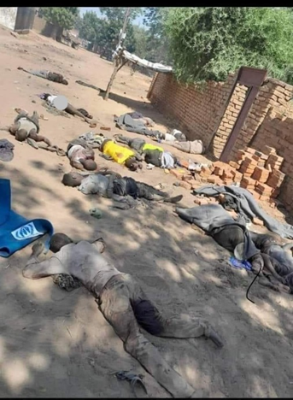

Source: Widely circulated photo, verified by the Panel.

100. RSF and allied militias arbitrarily detained and tortured hundreds of male adolescents and adults. A survivor interviewed by the Panel reported being detained and tortured along with several hundred other detainees, of whom only four escaped. According to eyewitnesses, although women were not targeted directly, some were killed by random shooting and subjected to sexual violence. Although overall death estimates were difficult to establish, reports indicated 800 to 2,000 killings, while many people were also reported missing. According to survivors, RSF and allied militias forced civilian detainees to collect the bodies and bury them. The Panel received information of at least three mass graves.

VII. Case study 2: conflict dynamics in Nyala

A. Overview

101. In August, RSF intensified its operations to capture Nyala when faced with difficulties in achieving its remaining military objectives in Khartoum. Nyala was the second-largest city in the Sudan and a commercial hub with South Sudan and the Central African Republic. Testifying to the importance of taking the city, the RSF deputy commander-in-chief, Abdelrahim Dagalo, oversaw the assault.
102. In July, RSF besieged the 16th Division headquarters. On 26 October, RSF forces took control of the base after a four-day assault and gained full control of the city and South Darfur State. The base housed a crucial component of the SAF western region command, including artillery, engineers and armoured vehicles.
103. The RSF victory was helped by internal divisions in the SAF garrison, illustrated by the killing of a SAF commander, Yasser Fadlallah al-Khidr al-Saim, on 21 August by one of his soldiers and the defection of dozens of SAF soldiers. The final RSF takeover was the outcome of negotiations between RSF and the new SAF commander, Brigadier General Hussein Muhammad Jawdat.
104. On 22 November, RSF issued directives to address violations in Nyala, emphasizing a semblance of governance. Abdelrahim Dagalo urged inhabitants to return to their homes. RSF directed police and community leaders to manage the day-to-day governance of the city.

B. Large recruitment drive in South Darfur prior to the conflict

105. During February and March 2023, numerous young people from rural areas in South Darfur were assembled in Nyala and subsequently sent to RSF training camp located in the Khartoum area, such as Tayba and Omdurman. Eyewitnesses and video footage confirmed the presence of trucks transporting those recruits inside Nyala. The recruits hailed from local Arab communities, including Tarjam (Bulbul Timbisco area), Beni Halba (Eid al-Fursan), Habbaniyah (Buram), Taisha (Am Dafok area), Sa’ada (Gardut area), Misseriya (Nitega area) and Fallata (Tulus area).
106. In exchange for providing RSF with several hundred members from their communities, the native leaders were granted incentives such as cars, money and, in some cases, RSF military ranks. Multiple sources within the traditional leadership corroborated those arrangements. For example, the nazir (highest traditional leader) of Fallata, Mohamed al-Futi Ahmed al-Samani, a close associate of Hemedti after the December 2018 revolution, actively participated in selecting members of his community, including Abdallah Yagoub, who became one of the prominent RSF commanders in Nyala.
107. Some RSF officers also played pivotal roles in the recruitment process. Notably, Taha Humaidan, a prominent member of the RSF peace committee in Darfur and a relative of Hemedti, along with al-Nazir Yunis, hailing from the Misseriya community and another key committee member, took charge. As part of their work in the RSF peace committee that served as a mediator in various intercommunal conflicts, the officers established strong ties with numerous traditional leaders, which proved advantageous for RSF in the recruitment efforts.

C. Coordination between military and native leaders

108. As in West Darfur, RSF offensives against the SAF division in Nyala received assistance from members of several Arab communities who were recruited and armed for the operations. Those local militia members, often traveling by motorcycle, were involved in various activities such as attacks on individuals, burglaries, looting and theft of international non-governmental organizations’ cars.
109. The mobilization of armed members from local Arab communities was facilitated by traditional chiefs. The nazir of Tarjam, Mohamed Ibrahim, publicly called upon his community to support RSF, resulting in numerous Tarjam members arriving in Nyala to back RSF and participating in looting. Similarly, on 17 May, the nazir of Misseriya, Al-Tijani Abdulgadir Mohamed Osman, released a statement in which he expressed support for RSF. Osman al-Nur, an omda (traditional leader) from the Awlad Rashid community, also mobilized members of his community to support RSF. In addition, the Fallata nazir sent several dozen fighters to support RSF in Nyala.
110. RSF officers also played a significant role in mobilizing militias by enlisting members from their own communities to support RSF. During clashes with SAF, al-Nazir Yunis mobilized members of his Misseriya community, leading to heavy losses among them. Another important RSF commander, Adam Aboushanab, who was actively involved in RSF mining companies in South Darfur, recruited several dozen members from his Ereigat community to support RSF efforts.

D. Violations of international humanitarian law in Nyala

111. According to local sources, RSF and allied militias infiltrated and took control of civilian neighbourhoods and looted and occupied homes and public buildings. Indiscriminate and disproportionate heavy artillery shelling from SAF towards suspected neighbourhoods resulted in the heaviest losses of civilian life, with artillery hitting people’s homes. In retaliation, RSF shelling targeting the SAF 16th Division hit the civilian neighbourhoods near the base. Many civilians died in the crossfire from the warring parties. For example, on 21 August, SAF shelling hit a market, killing 24 people. Similarly, on 22 August, approximately 41 civilians, mainly women and children, were killed from SAF shelling when sheltering under the Taiba bridge in South Nyala.
112. The SAF military response took on a new dimension on 3 and 13 September, when, for the first time in Darfur since the conflict started, SAF used aerial bombings on civilian neighbourhoods. Local sources reported that at least 54 civilians were killed by the airstrikes and many injured amid limited medical care facilities, given that there was only one functioning hospital. The continued shelling and additional aerial bombing destroyed much of the city and its public infrastructure, including the main market. Interrupted communication networks severely hampered the monitoring of the situation. Water and electricity services were cut off and access to food was limited. There was little access to markets, and many struggled to pay for goods because there were no economic opportunities, while prices soared (see annex 4 to the present report for satellite imagery showing damage to Nyala).
113. Death estimates were difficult to confirm. The heavy shelling and aerial bombing led to a significant surge in forced displacement, South Darfur being the state from which most internally displaced persons fled in Darfur, with approximately 794,000 civilians fleeing to nearby localities to North Darfur (El Fasher) and East Darfur (Ed Daein).
114. Furthermore, RSF and allied militias arbitrary arrested and detained, kidnapped and killed civilians, while also committing acts of sexual violence, looting and recruiting children (see paras. 61–67 above).

VIII. Financing of the warring parties in Darfur

A. Overview

115. By the time the current conflict erupted, RSF and SAF already had substantial financial means in the Sudan and the region. RSF, for example, controlled most of the gold trade in the Sudan. RSF invested large proceeds from the gold business in several industries. While SAF also controlled several important economic sectors and companies, its profits from these eroded following the beginning of the war, given that many of these assets were headquartered or based in Khartoum. Currently, SAF relies in large part on wealthy individuals and businessmen aligned with it to finance its military capability.
116. RSF and SAF drew on those investments and resources, some of which were owned through proxy and subsidiary companies, to fund their operations. This was used to acquire weapons, pay salaries, fund media campaigns, conduct lobbying and buy support of other political and armed groups, including in Darfur.
117. During the reporting period, the Panel received information that up to 50 companies associated with RSF were directly or indirectly funding the force. The Panel was able corroborate that several of those companies, most of which were based in regional countries, were owned by senior members of RSF and their associates. An analysis of that information revealed investment in multiple sectors, including mining, security, agriculture, manufacturing, real estate, construction and services such as consultancy and tourism. Accordingly, for example, the Al-Junaid Company for Multi Activities was the holding company of various entities as depicted in figure I. The company was owned by Abdelrahim Dagalo (RSF deputy commander-in-chief) and Abduljabbar Mohamed Ahmed (believed to be a relative of the Dagalo family). The Panel estimated that the total value of the Al-Junaid Company for Multi Activities holdings amounted to several million dollars.

Figure I

Multi-sector investment of Al-Junaid Company (associated with RSF)
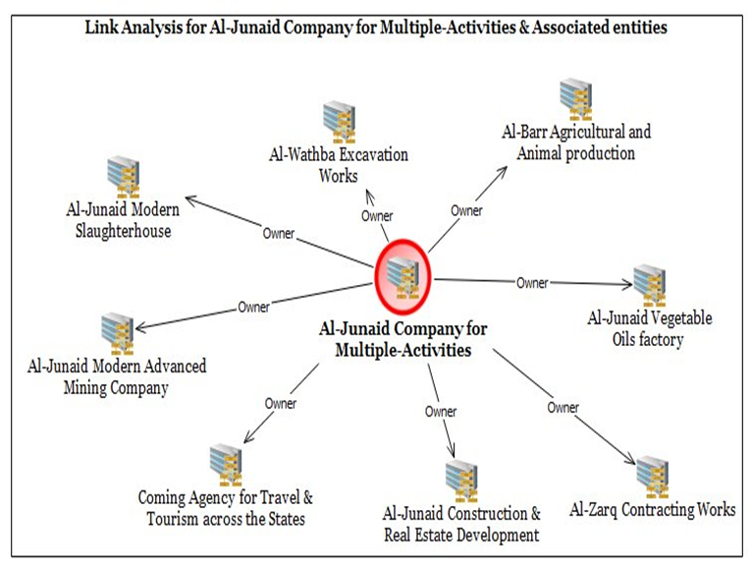

Source: Based on information and documentation received by Panel from confidential sources, August and December 2023.

B. Proxy companies

118. RSF has invested in multiple proxy entities outside of the Sudan during its existence. These entities, identified by the Panel, continue to change ownership and the nature of business in order to evade scrutiny. This was coupled with the continued recruitment of individuals in the Sudan and in the region to help to manage those entities and their changing ownership. In Dubai, United Arab Emirates, for example, a former senior official of the Central Bank of Sudan became the RSF financial adviser, helping it to manage this complex web of proxy companies and entities.
119. According to multiple confidential sources and documents consulted by the Panel, Al Khaleej Bank became instrumental to RSF financing when the majority of ownership of the Bank was acquired by individuals and entities associated with RSF in 2019. Confidential sources shared documentation with the Panel showing that, in March 2023, a few weeks before the war started, a $50 million transfer was made from the Central Bank of Sudan to Al Khaleej Bank. This operation reportedly was the reason behind the dismissal of the Central Bank Governor, Hussain Yahia Jankol, on 14 May, given that he was deemed pro-RSF.
120. Another striking example of this modus operandi was the Cadex Explosives for Civil Purposes company, owned in part by RSF associates, which owned shares in multiple other entities, as shown in figure II. Those proxy companies continued to provide financial support to RSF activities.

Figure II

Multi-layered ownership of companies associated with RSF

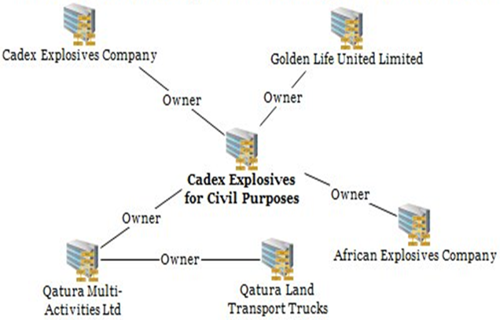

Source: Based on reports and information received by the Panel in August 2023.

C. Internal financing

121. Immediately after the war began, on 18 April the Sudan Ministry of Finance stopped salary payments to RSF members. However, that development did not affect RSF military operations. RSF began to pay its main commanders directly, in cash. For example, RSF sources reported to the Panel that Juma Dagalo, Hemedti’s uncle who oversaw RSF operations in Zuruk (North Darfur), was receiving regular payments from RSF.
122. The Panel also received information that RSF and SLA/MM, among other armed groups, were extorting payments for safe passage and protection from convoys and vehicles that were passing through their areas of control in Darfur. After taking control in most parts of Darfur, RSF established several checkpoints and roadblocks along the traditional trade routes, such as from El-Obeid to El Fasher, and from Am Dafok to Nyala. SLA/MM and other Juba Agreement for Peace in the Sudan signatory groups formed similar checkpoints in North Darfur, in particular roads to Libya.
123. The Panel also documented details of smuggling operations and other criminal activities carried out by various armed groups, including Juba Agreement for Peace in the Sudan signatories and RSF. For example, those groups smuggled looted goods, including vehicles, from Khartoum to Chad through Darfur.

D. Mineral resources/gold

124. Notwithstanding a significant decrease in production owing to the war, gold continued to be a source of revenue for the warring parties. A governance vacuum and lack of control over the gold industry allowed gold smuggling networks to flourish. For example, a Sudanese gold trader associated with RSF received 50 kg of gold in Dubai in May 2023. The consignment, the first one since the outbreak of the war, came from Khartoum and transited through Port Sudan. Since the beginning of the war, most of the gold that was previously exported to the United Arab Emirates was now smuggled to Egypt.,

1. Gold mapping in Darfur/the Sudan

125. The Panel mapped gold and gold production in Darfur as part of the wider exercise of funding the conflict. Extensive research and analyses included interviewing experts with detailed and close knowledge of the trade, as well as documentation provided by confidential sources. While Darfur (with five states) was an important gold production area, it was not the largest gold producer. A total of 15 of 18 states of the Sudan produced gold, with Red Sea being the highest producer.
126. Sudan gold was mined in two ways: by concession companies and through artisanal mining across. Gold mined in Darfur, which RSF controlled in large part prior to April 2023, contributed a small percentage to the total gold produced in the country. Reports indicated that more than 50 per cent of the gold mined in the Sudan was not traded through the formal channels but was smuggled out of the country. RSF had two documented concessions companies operating in Darfur in Radom, Singo Aghbash and Daraba in South Darfur.

2. Artisanal gold mining in Darfur

127. Artisanal mining accounted for 30 per cent of the gold mining in the Sudan. In Darfur, for example, artisanal mining took place in several mines controlled by various armed actors, including RSF, SLA/AW and local ethnic militias, such as from the Sa’ada in South Darfur. SLA/AW controlled gold mines in Jebel Marra, in particular in Turiyah.

IX. Mediation initiatives

A. Overview

128. Since the beginning of the conflict, various regional and international actors launched mediation initiatives: the African Union, the Intergovernmental Authority on Development (IGAD), the group of neighbouring countries and the Jeddah initiative on a ceasefire. Those initiatives resulted in the creation of various working groups and committees and the formulation of road maps aimed at solving the Sudanese crisis. However, none of the recommendations and commitments stemming from the initiatives, such as the establishment of humanitarian corridors, were implemented. The excess of mediation tracks and insufficient coordination, as well as entrenched positions of the warring parties combined with competing regional interests, meant that those peace efforts had yet to stop the war, result in a political settlement or address the growing humanitarian crisis.

B. African Union

129. The African Union continued its efforts to mediate in the Sudanese crisis, using various approaches and channels. At the end of August, the African Union announced its plan to organize in September a conference that would bring together leading Sudanese political parties and civilian organizations. At the time of writing, the conference, to be supervised by the African Union Commission, did not materialize owing to internal disagreements between the civilian forces and potential participation of the former ruling National Congress Party. The Commission also created an expanded mechanism and a core group on the Sudan. Since September, there has also been a parallel initiative to gather Sudanese political actors, spearheaded by the African Union Chairperson, Comoros President Azali Assoumani.
130. On 15 November, the Peace and Security Council of the African Union held a meeting on the Sudan, attended by representatives from Saudi Arabia, the United Arab Emirates and the United States of America. In its communiqué, the Council stressed that there should be one, unified international mediation initiative on the Sudan, under the joint leadership of the African Union and IGAD.

C. Intergovernmental Authority on Development

131. During the reporting period, IGAD tried to mediate in the conflict through the Quartet Group of Countries for the Resolution of the Situation in the Republic of Sudan (Djibouti, Ethiopia, Kenya and South Sudan), chaired by the President of Kenya, William Ruto. While RSF supported the IGAD role, SAF publicly rejected President Ruto’s involvement in the matter. On 10 July, in Addis Ababa, IGAD adopted a road map for peace in the Sudan and discussed the deployment of the Eastern Africa Standby Force, a suggestion immediately rejected by SAF. In a meeting held on 6 September, the Quartet Group stressed the importance of IGAD being present in the Jeddah process and the need for all-inclusive consultations with civilian actors.
132. Relations between SAF and IGAD improved recently, as illustrated by the visits of General al-Burhan to Nairobi and Djibouti and his meetings with President Ruto and the President of Djibouti and IGAD Chairman, Ismail Omar Guelleh, in November. Those improved relations paved the way for the Extraordinary Assembly of IGAD Heads of State and Government, held on 9 December, which focused on the Sudan. It was announced at the Assembly that both General al-Burhan and Hemedti had agreed to an unconditional ceasefire and a one-to-one meeting. However, the Ministry of Foreign Affairs of the Sudan officially denied that General al-Burhan had agreed to any of those conditions.

D. Jeddah talks

133. Early in May, talks on a ceasefire and humanitarian assistance started in Jeddah, under the auspices of authorities from Saudi Arabia and the United States. On 11 May, the parties signed the Jeddah Declaration of Commitment to Protect the Civilians of Sudan, in which they made a commitment to allow for humanitarian access and respect international humanitarian law. The Declaration was not implemented, and the talks first came to a halt in July.
134. On 4 November, during a second round of talks, the parties reaffirmed the Jeddah Declaration. In addition, among others, the parties agreed to participate in a joint humanitarian forum to guarantee humanitarian access. The talks were suspended again in December owing to a lack of progress. The main stumbling block between the two delegations was the RSF refusal to withdraw from Khartoum and other towns, a key SAF demand.

E. Neighbouring States’ initiative

135. Egypt hosted a meeting in Cairo on 13 July attended by neighbouring countries (Central African Republic, Chad, Eritrea, Ethiopia, Libya and South Sudan) to discuss the conflict in the Sudan and find regional solutions. The new initiative, as outlined in concluding statement of 13 July, was officially welcomed by both SAF and RSF. A follow-up meeting was held in Chad on 7 August, at which the foreign ministers of the neighbouring countries met. The attendees endorsed a plan to end the conflict, including three key components: a ceasefire; a comprehensive intra-Sudanese dialogue; and the facilitation of humanitarian access. A follow-up meeting ensued in New York on 20 September, on the side of the session of the General Assembly. At the time of writing, the initiative was continuing.

X. Impact of the situation in Darfur on the region

A. South Sudan

136. Since the beginning of the conflict, South Sudan has expressed interest in mediating the Sudanese crisis, given its historical, economic and security ties with the Sudan. The idea did not materialize because leading international and regional actors were sceptical about the political and financial capacity of the country to conduct and complete such a mission. According to Panel sources, SAF would have welcomed the strong involvement of South Sudan. On the other hand, RSF was more reluctant, doubting South Sudan’s neutrality.
137. The security of oil pipelines from Upper Nile and Unity States to Port Sudan remained the key priority to Juba, given that revenue from oil presents its main income. South Sudan maintained relations with both RSF and SAF to secure an uninterrupted transit of oil. South Sudanese and Sudanese interlocutors informed the Panel that, in June, South Sudanese officials negotiated with SAF additional security for the pipelines to avoid possible damage from Sudanese armed actors. In October and November, RSF guaranteed the South Sudanese authorities that it would not target oil facilities and that oil traffic would remain unaffected.
138. In October, South Sudanese authorities invited the Juba Agreement for Peace in the Sudan signatories to discuss possible solutions to the Sudanese crisis (see table 1 and para. 5 above) In November, South Sudan received delegation from the Forces of Freedom and Change-Central Council. As a result of the visit, the Council and South Sudan formed a joint committee comprising representatives from both the Council and the South Sudan mediation committee for peace in the Sudan.

B. Chad

139. The long border between Darfur and Chad, and the fact that several key Darfurian communities, including Zaghawa, Arabs and Masalit, were present in eastern Chad posed a risk of conflict spillover in border areas. The large-scale influx of refugees coming from West Darfur increased the tensions with host communities with respect to access to services, land and resources. The economic situation in eastern Chad deteriorated, given that the border closure reduced the basic imports from the Sudan, mainly cereals, sugar and fuel.
140. Chadian authorities took measures to mitigate security risks in the border areas. Immediately after the outbreak of the conflict in the Sudan, the Government of Chad established a committee to manage the Sudan crisis, gathering relevant ministers. The authorities also sent military reinforcements to the border area, to prevent infiltrations of armed individuals. On November 28, the Consul General of the Sudan in Chad, Gaddafi Abdullah, met the commander of the joint force, General Osman Bahar Itno, in the border town of Abeche. This was the first meeting between officials in the format of the joint force since the outbreak of conflict in the Sudan. The Chadian contingent of the joint force continued to patrol the border area with the Sudan on the line of Tine-Kariari and Tisi-Ade.
141. RSF established recruitment networks in Chad, among Arab communities in particular. For example, in late May, four RSF cars came to the area of Marada, the stronghold of the Rizeigat community in Chad, and returned to the Sudan with several dozen recruits, according to the Chadian military. While the Chadian authorities received information about the intrusion, they could not intercept the vehicles.
142. The Chadian authorities tried to play a role in the mediation initiatives, in particular through the neighbouring States’ initiative. For example, on 2 December, the President of Chad held a meeting with the former Prime Minister of the Sudan, Abdallah Hamdok, on the side of the twenty-eighth session of the Conference of the Parties to the United Nations Framework Convention on Climate Change, held in the United Arab Emirates, to discuss political solutions to the crisis in the Sudan. However, relations between the Government of Chad and SAF deteriorated drastically after the latter accused Chad of facilitating military support to RSF (see para. 41 above).

C. Central African Republic

143. The conflict in the Sudan had implications for the Darfur-Central African Republic border area, including flows of fighters and weapons (see paras. 50–52 above) and cross-border trade. At the beginning of the conflict, the Central African Republic contingent of the tripartite forces of 90 soldiers remained trapped in the Am Dafok area, on the Sudanese side of the border, before being able to withdraw. On 17 May, RSF captured Am Dafok, the main border post with Central African Republic. This facilitated RSF recruitment in north-eastern Central African Republic among Arab border communities, according to various sources in both countries.
144. In April and May, the economic situation in north-eastern Central African Republic deteriorated quickly because of the crisis in the Sudan. Widespread insecurity in South Darfur meant that the flows of agricultural goods and fuel from the Sudan to the Central African Republic stalled. This led to price increases and shortages of supplies, in particular in Birao and Ndélé areas, pushing Central African local traders to procure fuel in Uganda.
145. Control of the border by RSF after May resulted in an increase of cross-border trade, according to Sudanese and Central African traders interviewed by the Panel. Local traders reported to the Panel that RSF had negotiated with local border communities to guarantee the safe, unhindered passage of goods, from which RSF benefited by levying security taxes. The markets in South Darfur, for example in Am Dafok and Sungu, reopened to supply north-east Central African Republic with fuel and consumer goods.

D. Libya

146. The conflict in the Sudan had an impact on the security of southern part of Libya, when the General Command of General Khalifa Haftar’s LNA declared the closure of the southern border on 25 April and deployed reinforcements to the border. LNA authorities were concerned mainly that some Sudanese fighters might flee from North Darfur to southern Libya, which could further destabilize the area.
147. Cross-border trade between Libya and Darfur stopped at the end of April 2023. It resumed with commercial trucks heading from Kufra to El Fasher in May. The price of diesel per litre in southern Libya was $10 at the time of writing, while in Darfur it was $25, which fuelled smuggling of this key good from Libya to Darfur, including for the resupply of Sudanese warring parties.
148. Several major Darfurian armed groups based in Libya took advantage of the chaotic situation in the Sudan to return to Darfur and Khartoum areas, including SLA/AW and several SRAC factions. However, several Juba Agreement for Peace in the Sudan signatory groups maintained forces in Libya.

XI. Travel ban

149. In paragraph 3 (d) of its resolution 1591 (2005), the Security Council imposed a travel ban and asset freezing on four individuals, one of them being Musa Hilal Abdalla Alnsiem (permanent reference number SDi. 002). During the reporting period, the Panel received verified reports that Hilal had travelled to Chad in November 2023 by road and reached the capital, N’Djamena, where he held private meetings. Hilal remained in Chad at the time of writing. His visit to Chad constituted a violation of the travel ban provisions.

XII. Recommendations

150. The Panel recommends that the Committee:
(a) Remind the parties to the conflict in Darfur to adhere to their obligations under international humanitarian law, including their obligations to protect civilians from violence, including women and children, from sexual violence, and children from recruitment into their armed forces, and remind the warring parties that those who commit violations of international humanitarian law or other atrocities may be subject to targeted sanctions measures in accordance with paragraph 3 (c) of resolution 1591 (2005);
(b) Remind the warring parties and those who facilitate the transfers of arms and military materiel to Darfur of their obligations to comply with the arms embargo measures as stipulated in paragraphs 7 and 8 of resolution 1556 (2004), and reiterate that those who breach the arms embargo may be designated for targeted measures in accordance with paragraph 3 (c) of resolution 1591 (2005).

Annexes

Annex 1: Arms and ammunition used during the violence in El Geneina

- In their attacks on El Geneina, RSF and allied militias, in addition to using assault rifles and 12.7 and 14.5 calibre machines guns, also deployed heavier calibre weapons such as mortars, and rocket launchers.
- On 13 May, several local sources saw RSF members using a heavy gun mounted on a Landcruiser vehicle, in Al Madaris neighbourhood. Cartridges of 30x165mm High Explosive Round were found on the site after the vehicle left. Such ammunition is customarily used on aircraft guns, such as those equipping the Sukhoi and Mig in possession of SAF Air Force. Most likely, RSF, who are not known for having had access to aircraft guns, looted such guns from SAF during a battle, and fixed them on Landcruisers as anti-aircraft system.

Photo of a 30x165mm High Explosive Round cartridge, El Geneina, May 2023
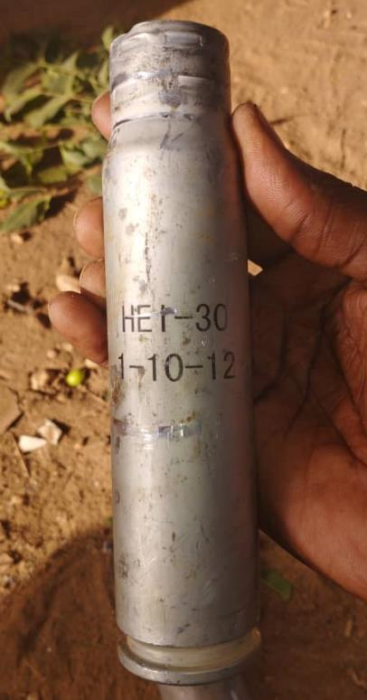
Source: Confidential

- From 12 May 2023 onwards, RSF and allied militias begun extensively using RPG-7 rocket launchers, mortars (60mm, 100mm and 120mm), and heavy rockets such as 107mm Type 63-2, a high-explosive surface-to-surface rocket, as illustrated by various videos of fighters, testimonies, and remnants of ammunition. Mortars in particular were used to target gathering sites in places such as Al Madaris areas.

Photo 5: Photo of remnants of RPG-7 ammunition (right) and of remnants of 60 and 100 / 120mm mortars (left), El Geneina, May 2023

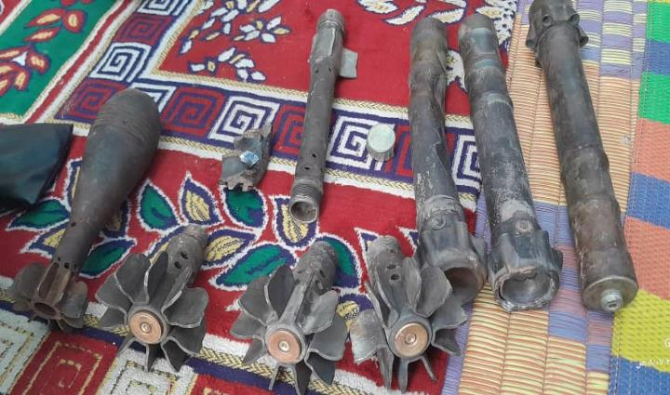
Source: Confidential

Photo 6: Photo of remnants of 1989-produced 107mm Type 63-2 rocket, El Geneina, June 2023
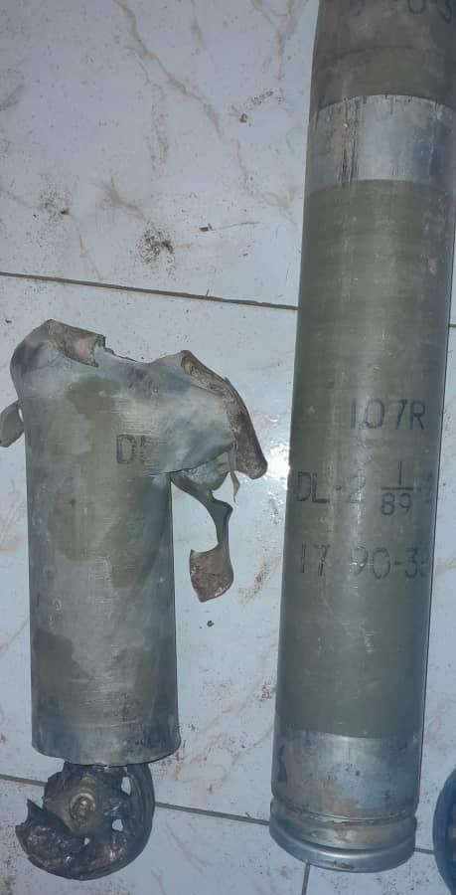
Source: Confidential

- Sudanese Alliance (SA), a JPA signatory movement, had about 25 vehicles based in El Geneina, mounted with 12.7mm and 14.5mm machine guns, and also had RPG-7, according to local sources and videos of the clashes. In early May, SA fighters started to run short of ammunition which led them to withdraw from the town on 14 June. In general, ammunition shortage was the main issue for SA as well as for Masalit self-defence groups.
Annex 2: Destruction and attacks in Zalingei

Map of IDP camps, with an overlay of verified fire and infrastructure damage from April until November 2023 in Zalingei, Central Darfur.
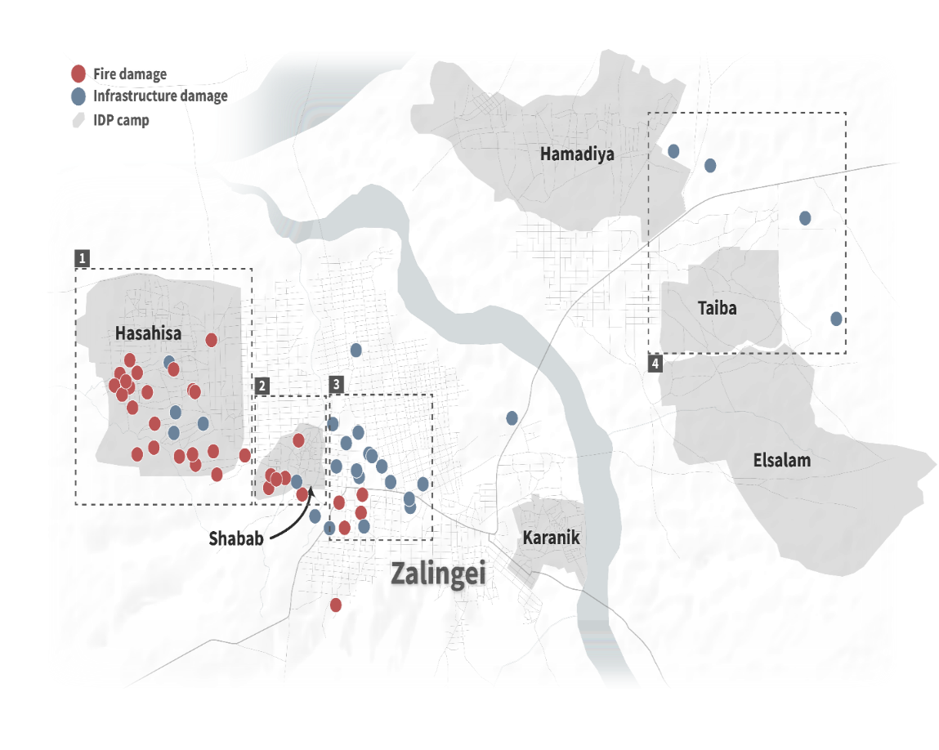
Sources: OpenStreetMap contributors, IOM DTM Round 6, Annotations by the Centre for Information Resilience (CIR). Prepared by CIR. (The boundaries and names shown and the designations used on this map do not imply official endorsement or acceptance by the United Nations)

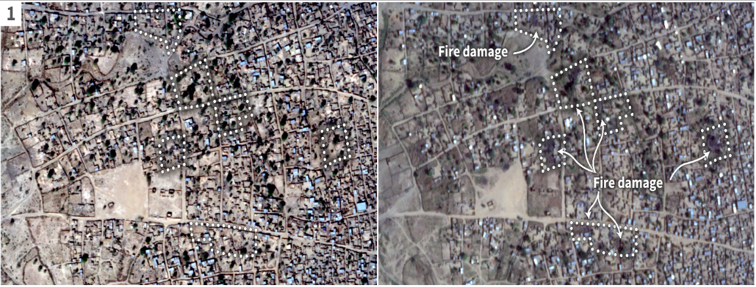

Satellite imagery showing fire and infrastructure damage in Hasahisa IDP camp, Zalingei. Left image-Obtained 8 Jan 2023. Right image-Obtained 11 Nov 2023.
Sources: Planet Labs PBC, Annotations by the Centre for Information Resilience (CIR). Prepared by CIR.

(The boundaries and names shown and the designations used on this map do not imply official endorsement or acceptance by the United Nations)

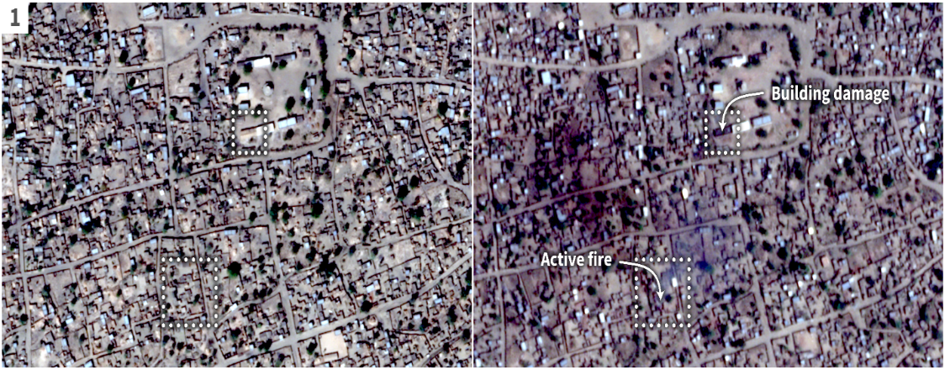
Satellite imagery showing active fire [12.90985,23.45163] and damage to infrastructure [12.91139, 23.45236] in Hasahisa IDP camp, Zalingei. Left image-Obtained 08 Jan 2023. Right image-Obtained 11 Nov 2023.
Sources: Planet Labs PBC, Annotations by the Centre for Information Resilience (CIR). Prepared by CIR. (The boundaries and names shown and the designations used on this map do not imply official endorsement or acceptance by the United Nations)
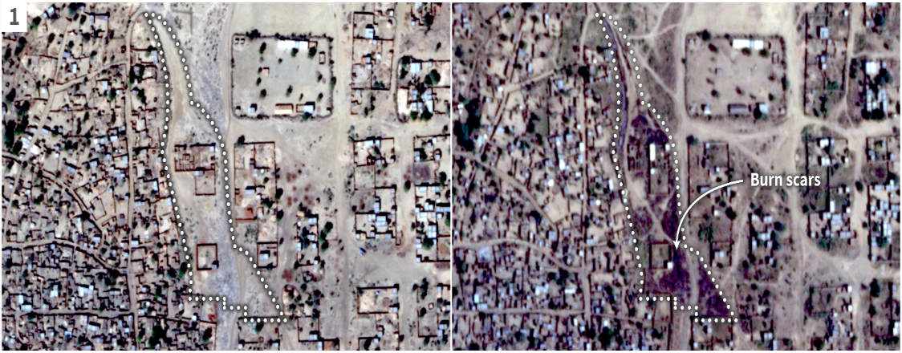

Satellite imagery showing burn scars in and around shelters in Hasahisa IDP camp, Zalingei. [12.91849,23.45597]. Left image-Obtained 08 Jan 2023. Right image-Obtained 11 Nov 2023
Sources: Planet Labs PBC, Annotation by the Centre for Information Resilience (CIR). Prepared by CIR. (The boundaries and names shown and the designations used on this map do not imply official endorsement or acceptance by the United Nations)

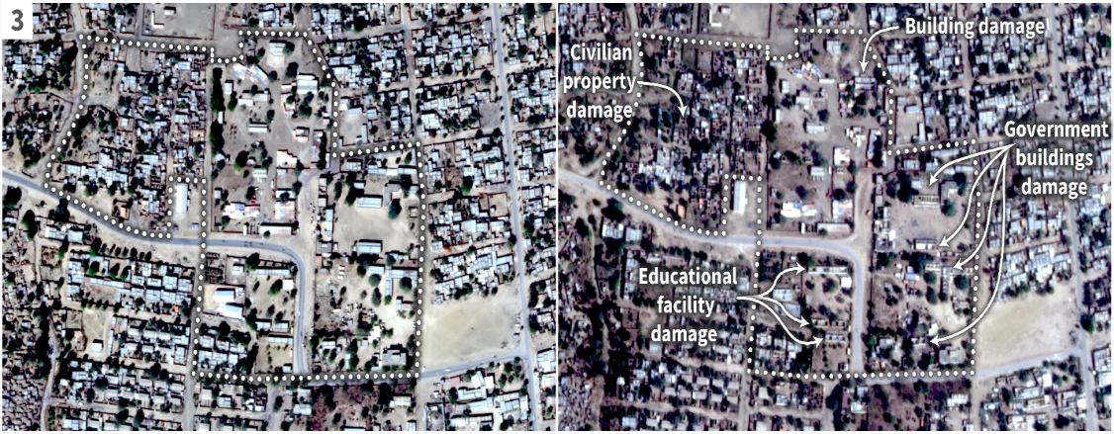

Satellite imagery showing damage to school buildings [12.90880,23.46955], government buildings [12.90956,23.47069], and civilian property [12.91046,23.46811] in Al Hai Al Gharbi, Zalingei. Left image-Obtained 8 Jan 2023. Right image-Obtained 11 Nov 2023.
Sources: Planet Labs PBC, Annotations by the Centre for Information Resilience (CIR).. Prepared by CIR. (The boundaries and names shown and the designations used on this map do not imply official endorsement or acceptance by the United Nations.)

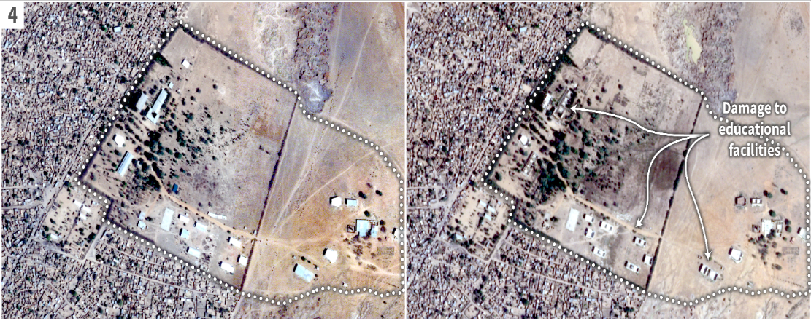
Satellite imagery showing damage to Zalingei University, School of Agriculture buildings east of Zalingei [12.93356,23.50195]. Left image-Obtained: 2 Mar 2023. Right image-Obtained 11 Nov 2023 (right).
Sources: Planet Labs PBC, Annotations by the Centre for Information Resilience (CIR). Prepared by CIR. (The boundaries and names shown and the designations used on this map do not imply official endorsement or acceptance by the United Nations.)

Annex 3: Destruction in El Geneina
map of IDP camps, with proximity to SAF & RSF bases and overlay of verified damage to infrastructure and IDP gathering sites from between 15 April to November 2023 in El Geneina, West Darfur.

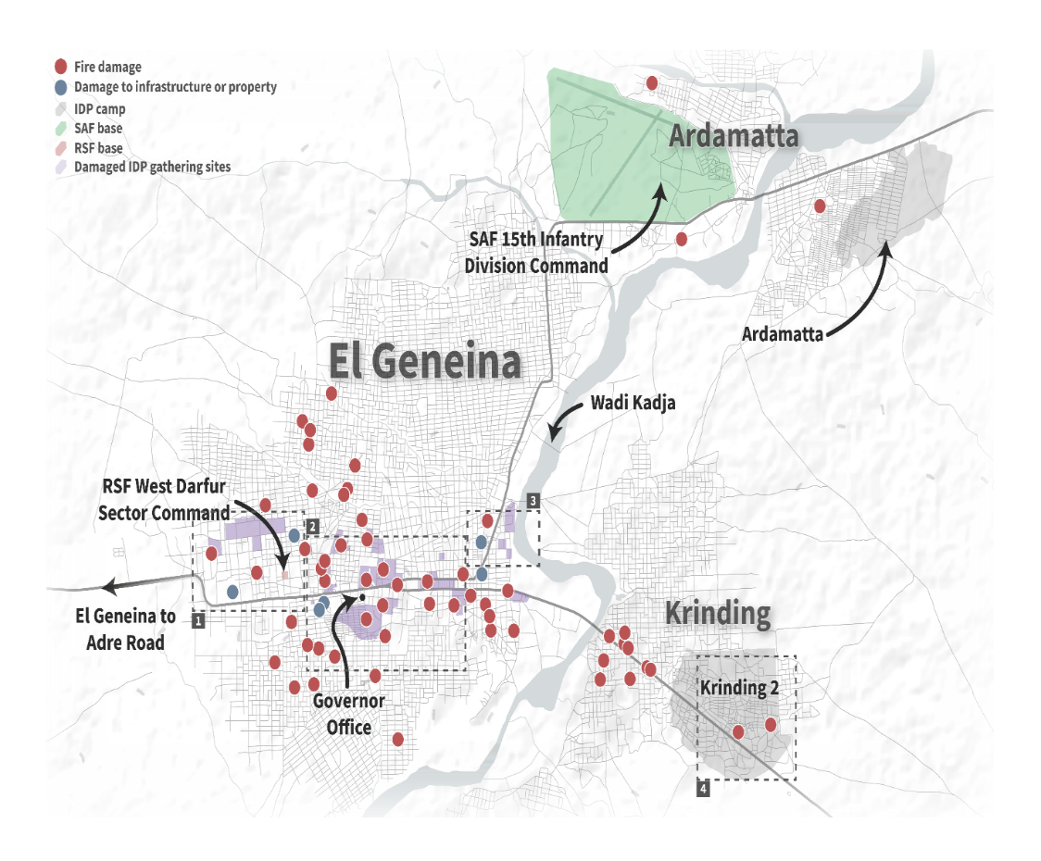
Sources: OpenStreetMap contributors, IOM DTM Round 6, Annotations by the Centre for Information Resilience (CIR). Prepared by CIR. (The boundaries and names shown and the designations used on this map do not imply official endorsement or acceptance by the United Nations.)

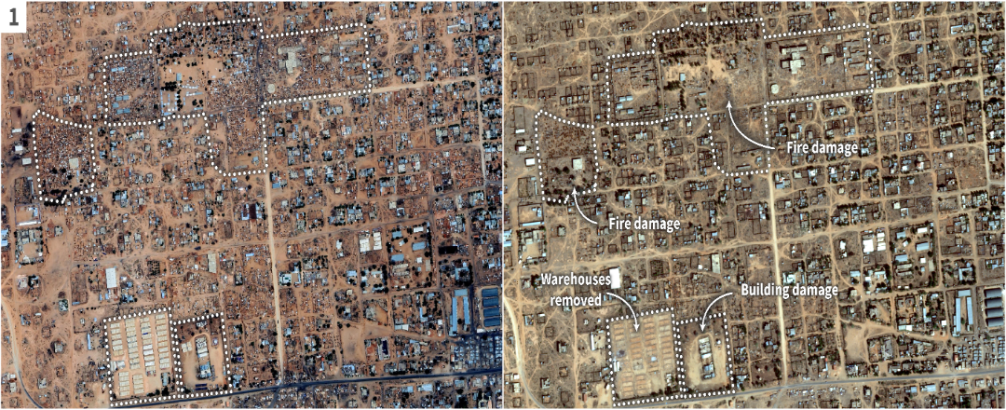
Satellite imagery of fire damage at IDP gathering locations and infrastructure damage west of El Geneina. Left image-Obtained: 19 April 2023. Right image-Obtained 17 November 2023.
Sources: Google Earth, Airbus DS, Planet Labs PBC, Annotations by the Centre for Information Resilience (CIR). Prepared by CIR. (The boundaries and names shown and the designations used on this map do not imply official endorsement or acceptance by the United Nations.)

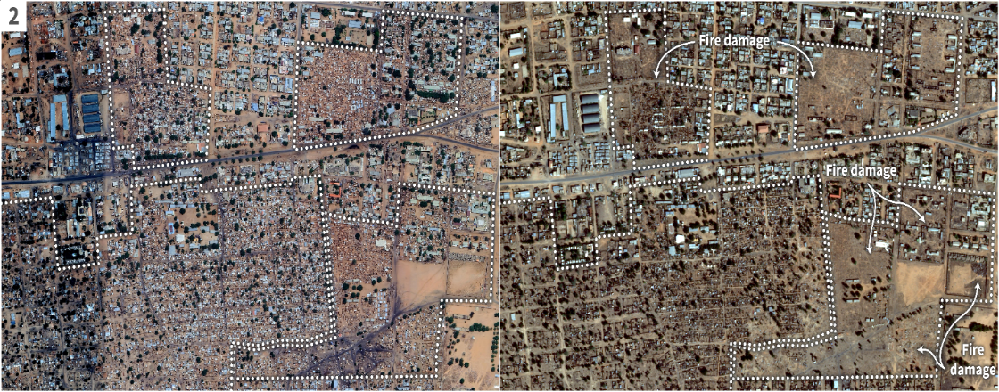
Satellite imagery of fire damage at IDP gathering locations, Abuzar, El Hujjaj, Al Jamarik IDP camps, and infrastructure damage in El Geneina. Left image- Obtained 19 April 2023. Right image -Obtained 17 November 2023 (right).
Sources: Google Earth, Airbus DS, Planet Labs PBC, Annotations by the Centre for Information Resilience (CIR). Prepared by CIR. (The boundaries and names shown and the designations used on this map do not imply official endorsement or acceptance by the United Nations.)

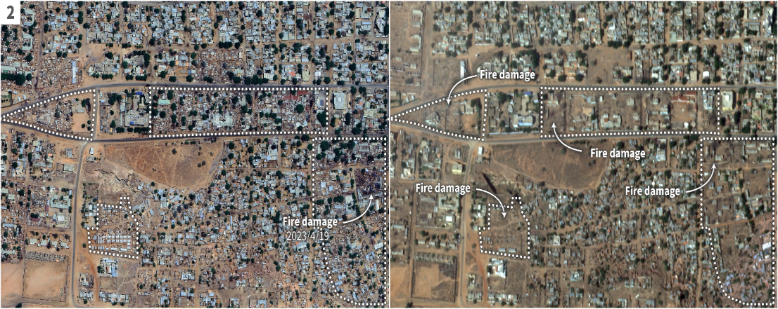Satellite imagery of fire damage at IDP gathering locations and infrastructure damage in Majlis and Al Tadamon neighbourhoods, El Geneina. Left image-Obtained 19 April 2023. Right image-Obtained 17 November 2023.
Sources: Google Earth, Airbus DS, Planet Labs PBC, Annotations by the Centre for Information Resilience (CIR). Prepared by CIR. (The boundaries and names shown and the designations used on this map do not imply official endorsement or acceptance by the United Nations.)

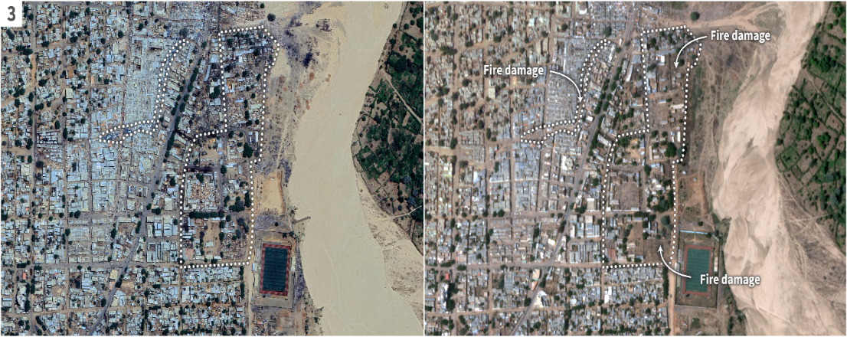Satellite imagery of fire and infrastructure damage in Al Nahda North and Al Zuhur neighbourhoods, east El Geneina. Left image-Obtained 19 April 2023. Right image-Obtained 17 November 2023.
Sources: Google Earth, Airbus DS, Planet Labs PBC, Annotations by the Centre for Information Resilience (CIR). Prepared by CIR. (The boundaries and names shown and the designations used on this map do not imply official endorsement or acceptance by the United Nations.)

Annex 4: Satellite imagery showing damage to Nyala
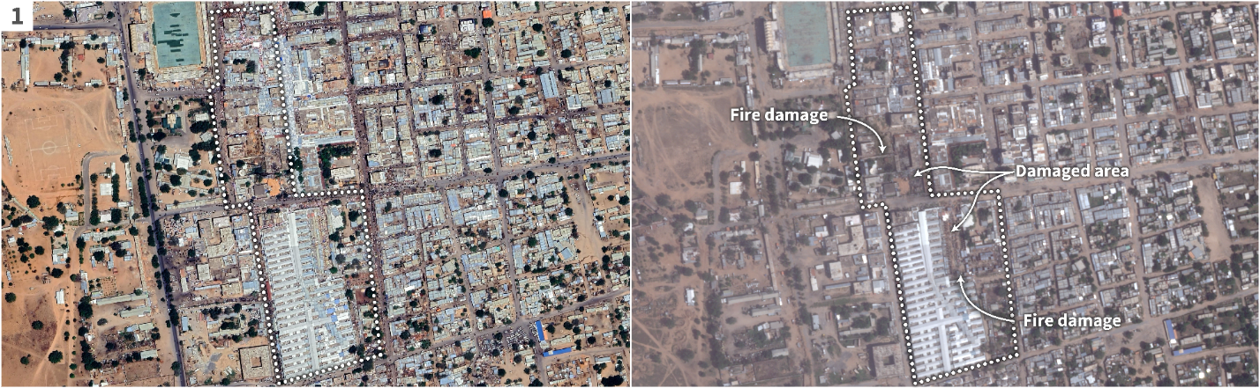
Satellite imagery showing damage to the Nyala Grand Market area east of SAF 16th Infantry Division command. Left image-Obtained 8 Apr 2023. Right image-Obtained 24 October 2023.
Sources: Google Earth, Airbus DS, Planet Labs PBC, Annotations by the Centre for Information Resilience (CIR). Prepared by CIR. (The boundaries and names shown and the designations used on this map do not imply official endorsement or acceptance by the United Nations.)
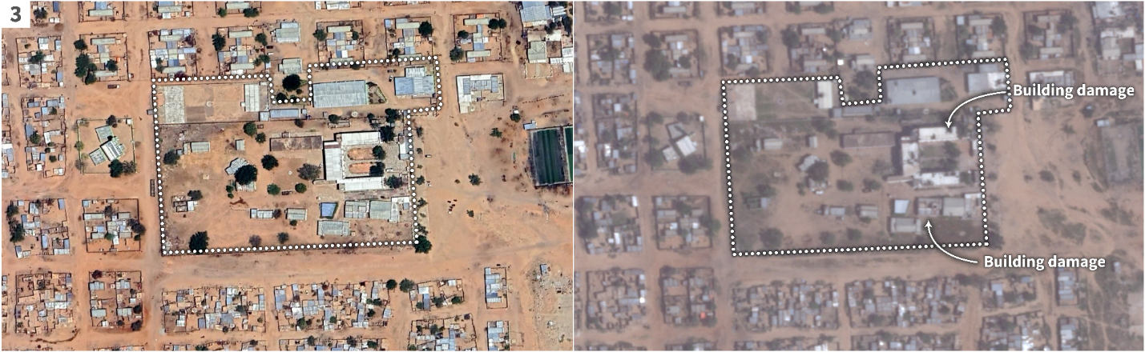
Satellite imagery showing damage to Nyala Military Hospital and surrounding buildings in Al Gomhuria neighbourhood, central Nyala. Left image-Obtained 8 Apr 2023. Right image-Obtained 24 October 2023.
Sources: Google Earth, Airbus DS, Planet Labs PBC, Annotations by the Centre for Information Resilience (CIR). Prepared by CIR. (The boundaries and names shown and the designations used on this map do not imply official endorsement or acceptance by the United Nations.)

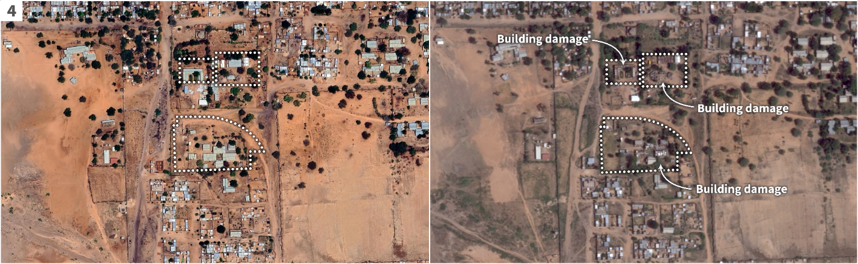
Satellite imagery showing damage to government and educational buildings in Karari East neighbourhood, Nyala, southeast from the SAF 16 Infantry Division. Left image-Obtained: 8 Apr 2023. Right image-Obtained 24 October 2023.
Sources: Google Earth, Airbus DS, Planet Labs PBC, Annotations by the Centre for Information Resilience (CIR). Prepared by CIR. (The boundaries and names shown and the designations used on this map do not imply official endorsement or acceptance by the United Nations.)

Annex 5: Letter addressed to the Panel from the Permanent Representative of the UAE to the United Nations
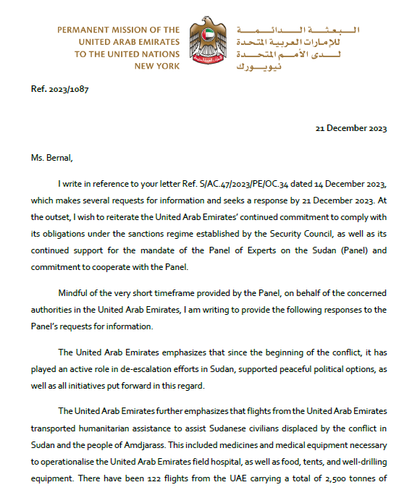

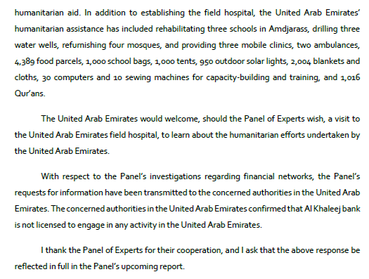

See https://twitter.com/RSFSudan/status/1725186152930414730?s=20.
See for example, Sudan Tribune, “Darfur leaders urged RSF to cease attack on El-Fasher, Idris says”, 12 December 2023.
See Ibid., “Another Darfur faction joins Sudanese army in fight against RSF”, 20 November 2023.
Ibid.
Interviews with members of the Darfurian armed movements, April–December 2023.
Signed in December 2022 by the military component of the Government (SAF and RSF) and several political parties and supported by the United Nations and the African Union, the framework agreement established a 24-month transition aimed at the establishment of a civilian-led Government.
This section is based on in-person and phone interviews with a broad range of interlocutors, including native leaders and relevant armed groups.
For one of the graduation ceremonies, held in October 2023, see: www.facebook.com/share/v/ 5ahvxZALeZdWHk5w/?mibextid=KsPBc6.
With regard to the creation of the “Kibir militias”, see Claudia Gramizzi and Jérôme Tubiana, Forgotten Darfur: Old Tactics and New Players (Geneva, Smalls Arms Survey, 2012).
Interviews with several community leaders and SA leaders, N’Djamena, and by phone, July–December 2023.
RSF fighters and allies frequently used the term “aleutaawa” (العطاوة) to name the coalition of Arab communities from Darfur and Kordofan.
With regard to the origins of Third Front-Tamazuj, see S/2022/48, annex 6.
See Sudan Tribune, “Tamazuj group aligns with RSF in Sudan’s ongoing war”, 17 August 2023.
A sub-market, Kajaik, was, for example, created in the Mawashi market, north of Nyala, controlled by Arabs, to sell guns and looted goods.
The Panel received several videos and testimonies about such “shops”.
In a video statement seen by the Panel, a Salamat commander accused Habbaniyah of having received 30 vehicles from SAF.
As observed by many eyewitnesses and confirmed by photo and video evidence.
See Sudan Tribune, “Sudanese army launches airstrikes on RSF base near Libyan border”, 2 September 2023.
See https://twitter.com/RSFSudan/status/1711483757411103161?t=WO_Kdj7r6Acfw4_nuDpT8g&s=08.
See, for example, Gerjon, “A new mystery airlift between the UAE and Africa”, 30 June 2023.
See Declan Walsh, Christoph Koettl and Eric Schmitt, “Talking peace in Sudan, the U.A.E. secretly fuels the fight”, New York Times, 29 September 2023.and Nicholas Bariyo and Benoit Faucon, “A U.S. ally promised to send aid to Sudan. It sent weapons instead”, Wall Street Journal, 10 August 2023.
See Sudan Tribune, “Sudan’s Sovereign Council member condemns UAE for arming RSF”, 28 November 2023.
See, for example, Agenzia Nova, “Soudan. Les Émirats démentent les allégations d’envoi d’armes et de munitions aux Forces de soutien rapide”, 14 August 2023.
Several photos attributed to members of the Chadian security forces reportedly show some shipments, including boxes of weapons and ammunition such as Type 56 assault rifles. See, for example, www.facebook.com/100064727614082/posts/pfbid0cc6qSijfU75eAZii79yVc34oiNV7Nwk2cngA9Cswa46NNGVpaF9gfCBxkjRNVPkdl/?d=n&mibextid=WC7FNe and www.facebook.com/ 100004271381101/posts/pfbid02aUUW5K7ixfu5jTsUhuEsX8VA7PAS6YaVVpRdQ6z8gBUk9jiYQL4BwVFUnCyjYkSMl/?d=n&mibextid=WC7FNe.
Hemetti’s clan settled in Zuruk around 2017, under the leadership of his uncle Juma Dagolo. On Zuruk and the RSF establishment there, see Klass van Dijken, “Blood, sand and gold: victor’s city rises from ashes of Sudan’s civil war”, The Guardian, 29 February 2020.
Information triangulated from several military and intelligence sources, and local interlocutors in the Sudan and Chad.
Interviews with the Government of the Sudan, United Nations officials and military sources.
On al-Jazouli’s past arms smuggling activities, see S/2019/930.
United Nations, Office for the Coordination of Humanitarian Affairs, “Sudan: humanitarian update”, 7 December 2023.
International Organization for Migration (IOM), “DTM Sudan: weekly displacement snapshot (13)”, 12 December 2023.
Office of the United Nations High Commissioner for Refugees (UNHCR), “Nearly 4,000 killed, civilian property destroyed in raging conflict in Sudan’s Darfur”, 17 October 2023.
Food and Agriculture Organization of the United Nations, “The Sudan: food security crisis intensifies amid ongoing conflict and economic challenges”, 3 August 2023.
Grave breaches of the Geneva Conventions of 1949; see also Rome Statute of the International Criminal Court, art. 8.
Prohibition of crimes against humanity is a peremptory norm of international law that binds all States; see also Rome Statute of the International Criminal Court, art. 7.
Interviews with survivors and local sources, September–November 2023.
Local sources; see also IOM “DTM Sudan flash alert: conflict in Zalingi (Zalingi town), central Darfur”, 1 November 2023.
The Darfur Bar Association confirmed 4 members killed in El Geneina and 3 in Nyala. Torture cases confirmed: 6 in El Geneina, 2 in Zalingei, 5 in Nyala and 3 in El Fasher.
Interviews with local monitors and activists, October–November 2023.
Interviews with local lawyers, October–November 2023.
Interviews with various journalists and activists and local sources, June–November 2023.
Interviews with various journalists, local monitors, activists, lawyers and community leaders in June, July, October and November 2023.
Interview with survivors, October 2023.
Ransom varied between 10,000 and 800,000 Sudanese pounds.
Credible local sources interviewed by the Panel, October–November 2023. See also Sudan Tribune, “Human rights defender fatally assassinated in South Darfur following abduction”, 4 August 2023.
The breakdown of the 262 cases by place of occurrence: RSF controlled areas in north El Fasher (27), Kutum (19), Tawilah (8), El Geneina (63) and Nyala (145).
Interviews with local monitors in Nyala, El Geneina, Zalingei and El Fasher throughout the reporting period.
Interviews with various local monitors and sexual and gender-based violence experts from the areas June, July, October and November 2023.
Interviews with local monitors, April–November 2023.
Interviews with local monitors and journalists, April–November 2023.
See https://twitter.com/RSFSudan/status/1723058260423365070?s=20.
See https://twitter.com/RSFSudan/status/1725466481901642062.
This section is based on interviews in Adré, Chad, Kampala and Nairobi; documentary evidence from United Nations agencies; interviews and documentary and photographic evidence from civil society organizations; and interviews with international NGOs, May–July 2023.
See IOM, “DTM Sudan: weekly displacement snapshot (13)”.
See https://twitter.com/rsfsudan/status/1669325565118107650?s=48&t=t9UpbqtEhdvNghN7ebfoOA.
See https://twitter.com/generaldagllo/status/1671142854108798976?s=48.
December 2019 and January 2020, Krinding I and II. See S/2023/93, sect. XI.
Legal cases concerning the 2019 Krinding attack and 2020 Misterei attacks.
Strategic Initiative for Women in the Horn of Africa, “Press statement: the footprints of genocide can be traced in Al Geneina”, 16 June 2023.
Communities fleeing the violence in Kuraynik, Sisi camp for internally displaced persons and Mournei were part of those seeking refuge.
Approximately 27–30 km.
On 16 June, Doctors Without Borders in Adré officially reported treating 622 injured within three days after the Wali had been killed. See Doctors Without Borders, “Over 600 war-wounded Sudanese arrive in Adré hospital in eastern Chad in the space of just three days”, 16 June 2023.
Many were stopped at Adikong. Reports confirmed various dead bodies in this area.
Between 30,000 and 40,000 Sudanese pounds per person.
See United Nations Integrated Transition Assistance Mission in the Sudan (UNITAMS), “SRSG for Sudan and Head of UNITAMS Volker Perthes remarks to the Security Council”, 13 September 2023.
See UNHCR, “Sudan: UNHCR warns of increasing violence and human rights violations against civilians in Darfur”, 10 November 2023.
Interviews with eyewitness and Chad entry point monitor, November 2023.
Interview with survivors, journalists, activists and community leaders, November–December 2023.
See Office of the United Nations High Commissioner for Human Rights, “Sudan: killings in Ardamata”, 17 November 2023.
Interview with Ardamatta survivors in Adré, Chad, November 2023.
See Sudan Tribune, “RSF kills over 2,000 civilians in West Darfur’s Ardamata”, 10 November 2023 and UNHCR, “Sudan: UNHCR warns of increasing violence and human rights violations against civilians in Darfur”.
Interview with Ardamatta survivors and local monitors in Adré, November 2023.
This section is based on in-person and phone interviews with a broad range of interlocutors from South Darfur, including native leaders and relevant armed groups, April–November 2023.
Ibid.
See Mat Nashed, “Sudan’s armed forces fails to protect civilians during air raids: activists”, Al Jazeera, 13 September 2023.
Local sources interviewed in October 2023; see also Sudan Tribune, “Artillery strike claims dozens of civilians in South Darfur capital”, 29 August 2023.
See IOM, “Regional Sudan response: situation update”, 21 November 2023.
See Reem Abas, “Money is power: Hemedti and the RSF’s paramilitary industrial complex in Sudan”, Tahrir Institute for Middle East Policy, 26 July 2023.
Including in military equipment production (Defence Industries System), charitable organizations and martyrs’ organizations, among others. See Suliman Baldo, “Sudan struggles to control its parastatals”, May 2021.
For example, the Panel received reports on various businessmen purchasing military equipment for SAF.
Several leaders and members of Darfurian armed movements acknowledged that their groups received money and logistics from the warring parties.
Confidential documents from sources within SAF and RSF. Other confidential sources directly involved in the transactions confirmed the veracity of those documents.
According to confidential documentation obtained by the Panel from a financial institution, they each owned 50 per cent of the shares as of July 2021.
Interviews conducted by the Panel in November and December 2023 gave various figures ranging from $5 billion to $10 billion as the net worth of the entity. Various reports consulted by the Panel demonstrate that, for example, in 2018 alone, RSF, whose mainstay company was Al Junaid, exported gold worth $30 million in a period of four weeks in 2018.
Interviews conducted the Panel in Cairo in September 2023 described the civilian RSF structure. This was also confirmed by the Panel’s local sources in November 2023.
RSF insider and intelligence sources, June and December 2023.
Confidential documents obtained and consulted by the Panel in August 2023. This was also collaborated with local sources in November and December 2023.
Multiple resources, including RSF insiders, shared this information with the Panel.
Various reports consulted by the Panel and interviews with confidential sources, November–December 2023.
See Sudeep Kainee, “Egyptian national arrested with 6.5 kg gold from Kathmandu airport”, Kathmandu Post, 10 December 2023.
Interviews with officials in the mining industry in the Sudan estimate the percentage of this to be 30 per cent.
See CGTN Africa, “More than 50 per cent of gold in Sudan is illegally smuggled out”, YouTube, 7 April 2023. Available at www.youtube.com/watch?v=gYdhLUaUzMk.
See S/2021/40, paras. 35 and 145–146.
The projected list of participants would include the Forces of Freedom and Change-Central Council, the Democratic Bloc, the Arab Socialist Ba’ath Party, the Communist Party of the Sudan, all Juba Agreement for Peace in the Sudan signatories, the Sudan People’s Liberation Movement-North Abdelaziz al-Hilu faction (SPLM-N) (Al Hilu faction) and the Sudan Liberation Army-Abdul Wahid (SLA/AW). See also Sudan Facts, “African Union preparing for inter-Sudanese dialogue”, 23 August 2023.
Interviews in person and by phone with SLA/AW, the Forces of Freedom and Change-Central Council, the Democratic Bloc, SPLM-N, former member of the transitional Government and Sudanese NGOs, in Cairo, Kampala, Juba, Nairobi and Addis Ababa, September–December 2023.
See African Union, communiqué of the 1156th meeting of the Peace and Security Council, Addis Ababa, 27 May 2023.
See https://beit-salam.km/actualit%C3%A9s/communique-presse-soudan.html.
See African Union, official communiqué of the Peace and Security Council, 15 November 2023.
See Sudan Tribune, “Sudan declines Kenya’s chairmanship of IGAD quartet”, 15 June 2023.
See Intergovernmental Authority on Development, communiqué of the 41st Extraordinary Assembly, Heads of the State and Government, 9 December 2023.
See Dabanga, “Sudan FA Ministry disavowal of IGAD communiqué ‘raises eyebrows’”, 12 December 2023.
Interviews in person and by phone with SLA/AW, Forces of Freedom and Change-Central Council, and Democratic Bloc members, diplomats, Sudanese politicians and former members of the transitional Government, Kampala, Cairo, Nairobi and Juba, September–November 2023. See also Sudan Tribune, “Mediators suspended Sudan’s ceasefire talks indefinitely”, 3 December 2023.
See https://shabait.com/2023/07/14/communique-of-sudans-neighboring-states-summit-cairo-13th-of-july-2023.
See State Information Service, “2nd meeting of FMs of Sudan neighbouring states convene in New York”, 20 September 2023.
Interviews with members of the Sudanese and South Sudanese armed groups, South Sudanese politicians, Darfurians and Sudanese diaspora in Egypt and Türkiye, April–July 2023.
See South Sudan, Ministry of Finance and Planning, first quarterly macroeconomic update, 2022/23 September 2022). Available at www.mofp.gov.ss/doc/Q1FY2022_ 23EconomicandBudgetImplementationReport.pdf.
Interviews with members of the Sudanese and South Sudanese armed groups and South Sudanese politicians, June–December 2023.
Interviews in person and by phone with SLA/AW and SPLM-N members, south Sudanese politicians and former ministers, Sudanese NGOs, and oil traders in Juba, Nairobi and Kampala, October–November 2023.
Correspondence and communication by phone with Sudanese diaspora, Sudan Liberation Army members in Nairobi and Kampala and Sudanese diaspora in N'Djamena, November–December 2023.
See www.dabangasudan.org/en/all-news/article/sudan-former-pm-hamdok-meets-with-chad-president.
See Sudan Tribune, “Sudan’s foreign minister rejects Chad’s demand for apology”, 11 December 2023.
See Zarambaud Mamadou, “Conflits au Soudan: des soldats centrafricains membres des forces tripartites en difficulté”, Oubangui Medias, 2 May 2023, and interviews with interlocutors from West and South Darfur, in Kampala, Cairo and Nairobi, May–June 2023.
Interviews with Sudanese, Ugandan and Kenyan traders and businessmen in Kampala and Nairobi, May–June 2023.
Interviews in person and by phone with businessmen from the Central African Republic, South Darfur and SPLM-N in Juba and Nairobi, October–November 2023.
See Ahmad El-Assasy, “Libyan army closes border with Sudan”, Libyan Review, 24 April 2023.
Cartridges, ammunition and unexploded ordnance collected by local civilians were inspected by the Panel.
About 13 cars for Bukhari Abdallah’s faction, about 9 for Wali, about 5 for Bahar Karama and about 4 for Abdu Al-Khlikh Dodeen.

